

August 7, 2026

Mr. Lamont Williams
Manager, Corporate Development Group 1 Realty, Inc.
730 Town & Country Blvd. Suite 500
Houston, Texas 77024

RE: Property Condition Assessment (PCA) Report
Porsche Atlanta Northwest 2501 Windy Hill Road SE Marietta, Georgia Inspection Date: 6.19.26

Dear Mr. Williams,

Southern Monitoring & Environmental, LLC (SM&E) has completed the authorized Property Condition Assessment (PCA) Survey for the above referenced property. The assessment was performed in conformance with the scope and limitations set forth by ASTM E2018-24 “Standard Guide to Property Condition Assessments: Baseline Property Condition Assessment Process”.
If you have any questions regarding this report or if we may be of further service to you, please contact the undersigned at (770) 653-4891.

Sincerely,

Kenneth Moore
Project Engineer/Inspector Enclosure: PCA Report

Atlanta, Georgia │ Jacksonville, Florida

Property Condition Assessment Report Porsche Atlanta Northwest

2501 Windy Hill Road SE Marietta, GA 30067

Prepared For:

Group 1 Realty, Inc.
730 Town & County Blvd.
Suite 500
Houston, TX 77024

Prepared By:

Southern Monitoring & Environmental, LLC
7265 Wingfield Way
Cumming, GA 30041

AUGUST 7, 2026

Executive Summary

Southern Monitoring & Environmental, LLC (SM&E) has performed a property condition assessment (PCA) of the parcels and improvements defined in the following table (the “subject property”). The assessment was performed in accordance with ASTM E2018-24 “Standard Guide for Property Condition Assessments: Baseline Property Condition Assessment Process”. The purpose of this Property Condition Assessment was to observe and document readily-visible materials and building system defects that might significantly affect the value of the subject property, and determine if conditions exist which may have a significant impact on the continued operation of the facility during the evaluation period.

Property Data
Name | Porsche Atlanta Northwest
Address | 2501 Windy Hill Road SE
City, State and Zip Code | Marietta, GA 30067
Property use | Automotive Dealership
Land acreage (acres) | 7
Number of buildings | Two buildings
Number of floors | Three
Year Built | 2024
Gross building area (SF) | ~60,694 SF for the dealership & ~5,040 SF for the detail Building
Foundation/Substructure | Concrete slab-on-grade with perimeter and interior footings under load bearing structures
Superstructure | I-Beam construction with steel supports and steel decking
Facade | Smooth metal decorative panels and corrugated steel panels
Roof Type | TPO on the dealership building & Standing seam metal roof on the detail building
Parking area | Asphalt paving & concrete
Parking space count | Three hundred seventy-one (371), twenty-seven (27) are customer parking
ADA-designated parking count | Six (6)
HVAC system | Thirteen (13) roof mounted units
Water supply piping | Copper
Electrical branch wiring | Copper
Number of elevators | One
Fire suppression | Wet-type fire suppression throughout the dealership
ii

Fire Alarm | Honeywell Fire Control Panel

The buildings on the subject property are further described as follows:

Structure | Address | Building Area (SF) | Construction Date
Automotive Dealership | 2501 Windy Hill Road SE Marietta, GA | ~60,694 | 2024
Detail Building | 2501 Windy Hill Road SE Marietta, GA | ~5,040 | 2024

Overall General Condition

Based on the systems and components observed during the site visit, the subject property appeared to be in good condition. The detailed observations of reviewed systems are presented in the following Sections of this report, with tabulated opinions of cost presented in the Appendices.

Level of Preventative Maintenance

Based on the systems and components observed during the site visit, the subject property appeared to be in good condition. The detailed observations of reviewed systems are presented in the following Sections of this report, with tabulated opinions of cost presented in the Appendices.

Summary of Significant Deferred Maintenance Items (>$3,000)
Based on the systems and components observed during the site visit, the subject property appeared to be in good condition. The detailed observations of reviewed systems are presented in the following Sections of this report, with tabulated opinions of cost presented in the Appendices.

Summary of Significant Pending or In-Progress Capital Improvements (>$25,000)

Based on the systems and components observed during the site visit, some components of the property required improvements. No significant pending or in-progress capital improvements were in progress at the time of the inspection.
Summary of Significant Recently Completed Capital Improvements (>$25,000)

Based on the systems and components observed during the site visit, the subject property appeared to be in good condition.

Immediate and Short-Term Repair Items
This report presents opinions of costs for items or conditions that require immediate action as a result of the following: Material existing or potentially unsafe conditions, material code violations, or any other physical deficiencies that if left uncorrected would be expected to result in or contribute to the failure of critical elements or systems within one year or may result in a significant increase in remedial costs. These items should be addressed at the first practical opportunity.

In addition, this report presents opinions of costs for items or conditions that may not require immediate action, but should be conducted on a priority basis above and beyond routine maintenance. Generally, the recommended time frame for addressing these items is two years. Deferred maintenance items and/or physical

deficiencies that are considered significant are also identified in Table 1 - Immediate Repair and Long Term Cost Opinion.

Reserve Items
In accordance with the terms under which this assessment was performed, this report includes opinions of costs for capital replacement reserve items that are anticipated to occur during a specified evaluation period. These items are identified in Table 2 – Needs Distribution of Long-Term Needs. Systems or components that are present at the subject property, but not listed in Table 2, are expected to realize a useful life that exceeds the evaluation period.

Schedule of Material Physical Deficiencies Summary
Sect. # | Remedy | Immediate Needs | Short-Term Needs | Long-Term Needs
3.2.4 | Clean, seal coat, & stripe parking lot and driveways (Year 3) |  |  | $78,300.00
3.2.4 | Clean, seal coat, & stripe parking lot and driveways (Year 8) |  |  | $78,300.00
The costs listed are based on SMEs’ historical cost for like items and is not intended to be an estimate for the work to be performed. Other contributing factors including inflationary, regional or contractor costs will affect the actual cost of the repair items throughout the term. SM&E recommends that the end user of this report obtain estimates from licensed contractors for specific work items to determine the actual cost for repairs.

Opinion of Costs
Opinion of Costs Summary
Total Evaluation Term (yrs): | 10
Inflation Factor: | 3.00%
Opinion of Costs: Immediate | $0
Opinion of Costs: Short-Term | $0
Opinion of Costs: Short/Long-Term-Uninflated | $156,660
Opinion of Costs: Short/Long-Term-Inflated | $179,385
Opinion of Costs: Short/Long-Term-Uninflated ($/SF/Yr) | $0.30
Opinion of Costs: Short/Long-Term-Inflated ($/SF/Yr) | $0.50
Recommendations of Additional Investigations
No recommended additional investigations.

Cost Exclusions

This report excludes costs for systems or components that are reported to be a tenant responsibility to maintain and replace, that are generally associated with the normal operation of the subject property, that are part and parcel of a building renovation program, for enhancements to reposition the subject property within the marketplace, for work that is cosmetic or decorative, for work that is being conducted for warranty transfer purposes, and routine maintenance activities. This report also excludes costs that are below the reporting threshold established by the engagement agreement.
iv

Deviation from ASTM E2018

The deviations listed below are part of SM&E’s standard operating procedures or were specified in the Client’s scope of work.

- This report includes seismic zone information that is not required by the Standard.
- The limited assessment of ADA needs and the provision of associated costs is not required by the Standard but has mutually agreed upon and included in the assessment.
- This report includes an opinion of costs for anticipated capital expenditures for an evaluation period defined by the Addressee and immediate and short-term costs. These costs are presented in Tables 1 & 2

Cost Exclusions

SM&E is an independent contractor who has been engaged by the Client to conduct a Property Condition Assessment.

Contents

Executive Summary ii
Contents vi
Acronyms and Abbreviations viii
Introduction 1
  - Purpose 1
  - Scope of Work 1
  - Cost Evaluation Methodology 1
  - Descriptive Qualifiers 1
  - User Reliance 2
  - Limitations 2
Reconnaissance, Regulatory, and Document Review 4
  - Site Reconnaissance 4
  - Property Personnel Interviewed/Contacted 4
  - Regulatory Compliance Inquiry 4
  - Document Review 5
  - Limitations 5
Property Characteristics 6
  - Parcel Configuration 6
  - Site Improvements 6
    - Topography 6
    - Storm Water Drainage 7
    - Ingress and Egress 7
    - Paving, Curbing, and Parking 7
    - Walkways, Grade-Level Steps, and Ramps 8
    - Landscaping and Irrigation 9
    - Retaining Walls 9
    - Site and Building Signage 9
    - Perimeter Walls, Gates, and Fences 10
    - Site Amenities 10
    - Special Utility Systems 10
    - Utility Service Providers 11
Structural Frame and Building Envelope 12
  - Foundation/Substructure 12
  - Building Frame 12
  - Facades or Curtain Walls 13
    - Exterior Walls 13
    - Doors, Windows, & Dock Doors 13
  - Roof 13
    - Roofing Materials 13
Mechanical and Electrical Systems 15
vi
  - Plumbing, Domestic Hot Water, and Sewer Systems 15
  - Heating, Air Conditioning, and Ventilation 15
  - Electrical 17
  - Lighting 17
  - Vertical Transportation 17
  - Life Safety and Fire Protection 18
    - Fire Suppression Systems 18
Interior Elements 19
  - Parts/Service & Showroom/Office Buildings 19
Non-ASTM Scope Considerations 20
Suspect Water Intrusion and Microbial Growth 21
Natural Hazard Information 22
  - Flood Zone 22
  - Seismic Zone 22
  - Wind Zone 22
Out of Scope Considerations 23
Limitations 25

Figures
Figure 1 Site Location Map
Figure 2 Site Plan
Figure 3 Flood Zone Map

Tables
Table 1 Immediate Repairs & Deferred Maintenance Cost Opinion Table 2 Long-Term Cost Opinion

Appendixes
Appendix A Photographic Log Appendix B Tax Assessor Information Appendix C Qualifications

Acronyms and Abbreviations

AC | Air Conditioning | kVA | Kilovolt-Ampere
ADA | Americans with Disabilities Act | kW | Kilowatt
AHU | Air Handling Unit | LED | Light Emitting Diode
amp | Ampere | LF | Linear Feet
BMS | Building Management System | LS | Lump Sum
BTU | British Thermal Unit | MAU | Make-up Air Unit
BUR | Built-up Roof | MBH | Thousand BTUs per Hour
CFM | Cubic Feet Per Minute | MEP | Mechanical, Electrical, and Plumbing
CMU | Concrete Masonry Unit | N/A | Not Applicable
EA | Each | NFPA | National Fire Protection Association
EIFS | Exterior Insulation and Finish System | OSB | Oriented Strand Board
EMS | Energy Management System | PCA | Property Condition Assessment

EPDM Ethylene Propylene Diene Monomer (Terpolymer)
PCR Property Condition Report

EUL Expected Useful Life PML Probable Maximum Loss
FACP Fire Alarm Control Panel PVC Polyvinyl Chloride
FCU Fan Coil Unit RUL Remaining Useful Life FEMA Federal Emergency Management Agency SF Square Feet
FF&E Fixtures, Furnishings, & Equipment SPF Spray Polyurethane Foam

FHA | Fair Housing Act or Federal Housing  Administration | SY | Square Yard
FIRM | Flood Insurance Rate Map | TON | Unit Cooling Capacity of an AC System
FOIA | Freedom of Information Act | TPO | Thermoplastic Polyolefin
GFCI | Ground Fault Circuit Interrupter | UBC | Uniform Building Code
HID | High Intensity Discharge | V | Volts
HVAC | Heating, Ventilation, and Air Conditioning | VAV | Variable Air Volume
IBC | International Building Code | WH | Domestic Water Heater

viii

SECTION 1.0

Introduction

Purpose
The purpose of this assessment is to provide information to evaluate the condition of the subject property in order to facilitate completion of due diligence by the addressee. The purpose is accomplished by describing the primary systems and components of the subject property, identifying conspicuous defects or material deferred maintenance, and presenting an opinion of cost to remedy the observed conditions. In addition, this report identifies systems or components that are anticipated to reach the end of their expected useful life during the specified evaluation period and includes an opinion of cost for future capital replacements.

Scope of Work
This assessment was performed in conformance with the scope and limitations as set forth by ASTM E2018-24 “Standard Guide for Property Condition Assessments: Baseline Property Condition Assessment Process” (the Standard) and as specified in the engagement agreement that initiated this work. Specific requirements or deviations from the minimum ASTM standard are described herein.
This assessment was performed utilizing methods and procedures consistent with good commercial or customary practices designed to conform to acceptable industry standards. The independent conclusions represent SM&E’s best professional judgment based upon existing conditions and the information and data available to us during the course of this assignment.

Cost Evaluation Methodology
Opinions of costs presented within this report are based on construction costs developed by construction resources such as Marshall & Swift, RS Means, and SM&E’s experience with past costs for similar projects, city cost indexes, consultations with local specialty contractors, client-provided information, and assumptions regarding future economic conditions. Actual cost estimates are determined by many factors including but not limited to: choice and availability of materials, choice and availability of a qualified contractor, regional climate zone, quality of existing materials, site compatibility, and access to the subject property and buildings. In addition, opinions of costs are based solely on material replacement and do not account for soft costs.
Items included in the replacement reserve table are determined based upon the estimated useful life (EUL) of a system or component, the apparent effective age (EA) of the system, and the remaining useful life (RUL) of that system. Factors that may affect the age and condition of a system include, but are not limited to, the frequency of use, exposure to environmental elements, quality of construction and installation, and amount of maintenance provided. Based on these factors, a system may have an effective age that is greater or less than its actual chronological age.

Descriptive Qualifiers
The following definitions and terminology are used in this report regarding the physical condition of the project, and the estimated life expectancies/age of the components and systems.
Good In working condition and does not require immediate or short-term repairs above an agreed threshold.

Fair In working condition, but may require immediate or short-term repairs above an agreed threshold.

1

Poor Not in working condition or requires immediate or short-term repairs substantially above an agreed threshold.
The agreed threshold is presumed to be the de minimis reporting threshold, unless otherwise specified in this report.
Unless stated otherwise in this report, the systems reviewed are considered to be in good condition and their performance appeared to be satisfactory.

User Reliance
SM&E was engaged by Group One Automotive (Addressee), or their authorized representative, to perform this assessment. The engagement agreement specifically states the scope and purpose of the assessment, as well as the contractual obligations and limitations of both parties. This report and the information therein, are for the exclusive use of Group One Automotive, its Subsidiaries and Their Successors and/or Assigns. This report has no other purpose and may not be relied upon, or used, by any other person or entity without the written consent of SM&E. Third parties that obtain this report, or the information therein, shall have no rights of recourse or recovery against SM&E, its officers, employees, vendors, successors or assigns. Any such unauthorized user shall be responsible to protect, indemnify and hold SM&E, the Addressee and their respective officers, employees, vendors, successors and assigns harmless from any and all claims, damages, losses, liabilities, expenses (including reasonable attorneys’ fees) and costs attributable to such use. Unauthorized use of this report shall constitute acceptance of, and commitment to, these responsibilities, which shall be irrevocable and shall apply regardless of the cause of action or legal theory pled or asserted.

Limitations
Building Assessment Reports as performed by SM&E are based upon our review of the subject property consisted of a visual inspection of the site, the structure(s) and the interior spaces. Technical Assessments were made based on the appearance of the improvements at the time of this Assessment. No destructive or invasive testing was included in the scope of this review.
No warranty is expressed or implied, except that the services rendered have been performed in accordance with generally accepted Assessment practices applicable at the time and location of the study.
This report should not be construed as technically exhaustive. This report does not warrantee or guarantee compliance with any Federal, state or local stature, ordinance or regulation including but not limited to, ADA, building codes, safety codes, environmental regulations, health codes or zoning ordinances or compliance with trade/design standards or the standards developed by the insurance industry. Local, state and federal regulations, and codes change significantly over time from when the subject property was developed and the subject building was constructed. The subject property and subject building may not meet all current regulations, and code requirements put forth on a local, state, or federal level.
SM&E has made reasonable efforts to properly assess the property conditions within the contracted scope of services; however, limitations during the assessment may be encountered. Please refer to Section 2.1 for a description of limiting conditions.
SM&E’s findings and conclusions are based primarily on the visual assessment of the property at the time the site visit and limited to the components of the building, this is not an environmental inspection and therefore No identification of Asbestos, Lead and Mold can be given. In addition, the assessment value is based upon comparative judgments with similar properties in the property observer’s experience. The Client is herewith advised that the conditions observed by SM&E are subject to change. SM&E’s property observations included

2

areas that were readily accessible without opening or dismantling secure areas or components. SM&E believes that the inferences made are reasonably representative of the property.
SM&E’s conclusions did not include any review of building department documents or the review of plans of any kind, destructive or invasive testing, laboratory analysis, exploratory probing or engineering evaluations of structural, mechanical, electrical, or other systems with related calculations.
No assessment can wholly eliminate the uncertainty regarding the presence of physical deficiencies and performances of the building system. According to the ASTM guidelines, a Property Condition Assessment (PCA) or Building Assessment Report (BAR) is intended to reduce the risk regarding potential building system and component failure. The ASTM standard recognizes the inherent subjective nature of the assessment regarding such issues as workmanship, quality of care during installation, maintenance of building systems and remaining useful of the building system or components.

3

SECTION 2.0

Reconnaissance, Regulatory, and Document Review

Site Reconnaissance
Date: June 19, 2026
Weather: Sunny
Field Assessor: Kenneth Moore
Escort: Graig Anderson (Corporate Controller)

The performance of this assessment was limited by the following condition(s):

    - A pre-survey questionnaire was not completed by the owner at the time of the assessment.

Property Personnel Interviewed/Contacted
The following personnel associated with the subject property were interviewed as part of the preparation of this report. Information obtained from the interviews is incorporated into the appropriate Sections of this report.

Individual | Position or Title | Contact Number/Email
Mr. Craig Anderson | Corporate Controller | 404-867-8930

The people interviewed were cooperative and appeared to have general knowledge about the subject property history and maintenance practices.

Regulatory Compliance Inquiry

Building Codes: |  | The City of Marietta Code Enforcement Division
Contact: |  | Kmoore2@mariettaga.gov |  |  | Telephone: |  | 770-794-5439
Findings: | No Violations |  | Violations |  |  |  |  | Awaiting response X
Findings: | An email was submitted to code enforcement on August 9, 2026, SM&E is awaiting a response.
Fire or Life Safety: |  | City of Marietta Fire Marshal
Contact: |  | FireMarshall@MariettaGa.gov |  |  | Telephone: |  | 770-794-5450
Findings: | No Violations |  |  | Violations |  | Awaiting response X
Findings: | An email was submitted to fire marshal on August 9, 2026, SM&E is awaiting a response.
Zoning: |  | The City of Marietta Planning & Zoning
Contact: |  | Slloyd@mariettaga.gov |  |  | Telephone: |  | 770-794-5669
Findings: | No Violations |  |  | Violations |  | Awaiting response X
Findings: | An email was submitted to City of Marietta Planning & Zoning on August 9, 2026, SM&E is awaiting a response.

4

This information does not constitute a detailed regulatory-compliance investigation, and any code compliance issues noted in this report are based on information provided by the regulatory agencies noted above. If possible, the provided information was confirmed with on-site observations. Additional information that is received within 30 days of the site visit will be forwarded upon receipt.

Document Review

The following documents were readily available or provided to SM&E for reference as part of this assessment.
- The City of Marietta Property Appraiser’ Office
- Federal Emergency Management Agency (FEMA) flood hazard layer map

Limitations

Limitations are summarized as follows:
    - Access Limitations:
− None
    - Physical Obstructions to Observations:
− Portions of the building were not fully observable due to interior and exterior finishes and claddings, such as acoustical ceiling tiles or gypsum wall board, limiting observations of the floor/roof deck and walls.
− Observations of exterior walls were made from the ground level adjacent to the building.
    - Outstanding Information Requests:
− Not all documents or information requested from the Client were provided for review.

5

SECTION 3.0

Property Characteristics

The subject property is an automotive dealership that operates as Porsche Atlanta Northwest. The subject property consists of one parcel approximately 7 acres. The subject site is located on the north side of Windy Hill Road SE.
A summary of the subject buildings is as follows:

Building Summary
Building Name | Building Description/Location | Year Constructed | Area (Net Leasable SF)
Porsche Atlanta Northwest | Dealership Building/Detail Building – 2501 Windy Hill Road NW Marietta, GA 30067 | ±2024  ±2024 | ±60,694  ±5,040

The subject property is bound by South Park Place followed by Chick-Fil-A to the east, an office park to the west, Windy Hill Road SE followed by a parking lot to the south, and a commercial building to the north.

Parcel Configuration
The subject property improvements include two buildings and an asphalt parking lot and concrete driveways located on one parcel (17080400140). The improved parcel is irregular in shape and is approximately 7 acres.

Site Improvements

Topography

The topography of the area is sloping towards the back or northeastern portion of the property and/or towards curb gutters.

Survey Condition and Analysis:

The topography of the property is appropriate for the property with drainage towards the north and east of the property.

Recommendations:
No recommended Immediate Needs, Short-Term Needs and Long-Term Needs were observed or reported at the time of our walk- through.

6

Storm Water Drainage
Storm water generally drains towards the northeast portion of the property and is captured by curbed gutters on the perimeter of the parking lot and then conveyed to a retention pond north of the dealership property.
Stormwater on the roof system is discharged to roof drains and conveyed to internal downspouts where they are plumbed underground to the subsurface storm water system.

Survey Condition and Analysis:

The storm water drainage systems appear to be in good condition.

Recommendations:
No recommended Immediate, Short-Term and Long-Term Needs were observed or reported at the time of our walk- through.

Ingress and Egress

Vehicular access is provided to the dealership by a gated entrance into the southern portion of the property along Windy Hill Road SE. Three additional controlled entrances are located to the east from South Park Place NW.

Survey Condition and Analysis:

Site access appears to be adequate for the site’s intended use. No issues regarding ingress/egress were observed or reported to SM&E.

Recommendations:

No Immediate Needs, Short-Term Needs, or Long-Term Needs were observed or reported at the time of our walk-through.

Paving, Curbing, and Parking

Asphalt pavement (~14,200 SY) and concrete pavement (~8,400 SY) was observed in the driveways and parking lots on the property.
Concrete curbs were observed on the perimeter of property and landscaped islands.

SM&E observed three hundred seventy-one (371) parking spaces present on the lot. Twenty-seven (27) customer parking spaces were present with six (6) handicap accessible parking spaces in front of the dealership.

Survey Condition and Analysis:

7

The asphalt and concrete pavement on the property appeared to be in good condition. Concrete curbs appeared in good condition.
No issues were reported regarding the adequacy of the car parking for the site’s current use. The current parking configuration does include six (6) handicap designated parking spaces which appear to be ADA-compliant, based on the number of public parking spaces provided. This is discussed further in section 7.1 of this report.

Recommendations:
No recommended Immediate Needs were observed or reported at the time of our walk- through. Recommended Short-Term Needs:
- Clean, seal coat & stripe parking lot and driveways. (Year 3)
- Clean, seal coat & stripe parking lot and driveways. (Year 8)

Walkways, Grade-Level Steps, and Ramps

Walkways, steps, and ramps are limited to conventional entrance landing pads, sidewalks, and equipment pads located inside the property line. Exterior steps are present connecting parking lots around the property. Ramps include an automotive ramp from the parking lot/driveway to the service department.

Survey Condition and Analysis:

The concrete walkways to the building are in good condition. The exterior steps and associated handrails appear to be in good condition. The ramp to the service department appeared in good condition.

Recommendations:
No recommended Immediate Needs, Short-Term Needs, or Long-Term Needs were observed or reported at the time of our walk- through.

8

Landscaping and Irrigation

Landscape vegetation consists of grass, trees, shrubs, and mulch within the parking area islands and perimeter areas of the property.

Survey Condition and Analysis:

Landscaping appeared to be in good condition.

Recommendations:

No recommended Immediate Needs, Short-Term Needs, or Long-Term Needs were observed or reported at the time of our walk- through.

Retaining Walls
Engineered block retaining walls are present along the western portion of the dealership building and the western portion of the parking lot.

Survey Condition and Analysis:

The retaining walls appeared in good condition during the site visit.

Recommendations:
No recommended Immediate Needs, Short-Term Needs, or Long-Term Needs were observed or reported at the time of our walk- through.

Site and Building Signage
Monument and building mounted signage were observed on the building along Windy Hill Road SE.

Survey Condition and Analysis:

The monument and building mounted signage appeared to be in good condition.

Recommendations:
No recommended Immediate Needs, Short-Term Needs, or Long-Term Needs were observed or reported at the time of our walk- through.

9

Perimeter Walls, Gates, and Fences
A 6’ chain-link cyclone fence is located on top of the retaining wall along the western portion of the dealership property.
Bollards are securing the northern, eastern, and southern perimeters of the dealership property.

Swinging pole gates are present at the entrance from the southern portion of the property along Windy Hill Road SE and from three entrances off South Park Place NW.

Survey Condition and Analysis:

The 6’ chain-link cyclone fence and retaining wall are in good condition and do not require any repairs. The swinging steel pole gates at the entrances of the property are in good condition.

Recommendations:
No recommended Immediate Needs, Short-Term Needs, or Long-Term Needs were observed or reported at the time of our walk- through.

Site Amenities
Recreational facilities and additional site amenities are not present.

Special Utility Systems
Special utility systems are not present. It should be noted that hydraulic lifts and other automotive-related servicing equipment are present at the site but are not included in the PCA ASTM standards.

10

Utility Service Providers

Utility | Provider | Meter configuration and location
Storm Water | Marietta Stormwater Division | Not Applicable
Electric | Marietta Power & Water | Power feed to building panels in parts department electrical room
Gas | Gas South | Western side of building
Water | Marietta Power & Water | The meter is located in the public right-of-way
Sanitary Sewer | Gwinnet County Water | Not Present

Survey Condition and Analysis
No issues or service deficiencies were reported. Routine maintenance is anticipated during the evaluation period.

11

SECTION 4.0

Structural Frame and Building Envelope

Foundation/Substructure
The building foundations are a concealed condition and could not be directly observed. Construction drawings of these systems were not provided for review. Based on experience with similar structures, the foundation system is believed to consist of concrete foundation walls and shallow reinforced concrete perimeter footings. The floor slabs consist of smooth-finished reinforced concrete slab-on-grade.

Survey Condition and Analysis:
The structural systems for the buildings appear to be in good condition and are free of visual signs of deficiency. No issues regarding the building structure were observed or reported to SM&E during our walkthrough.

Recommendations:
No recommended Immediate Needs, Short-Term Needs, or Long-Term Needs were observed or reported at the time of our walk- through. Normal monitoring of the foundation is anticipated during the evaluation period.

Building Frame

The building structures consist of I-Beam, steel columns, and structural steel roof/floor decking on the dealership.

Survey Condition and Analysis:

The structural systems for the buildings appear to be in good condition and are free of visual signs of deficiency. Evidence of structural distress indicative of framing failure was not observed. No issues regarding the building structure were observed or reported to SM&E during our walkthrough.

Recommendations:
No recommended Immediate Needs, Short-Term Needs, or Long-Term Needs were observed or reported at the time of our walk- through. Normal monitoring of the foundation is anticipated during the evaluation period.

12

Facades or Curtain Walls

Exterior Walls
Exterior walls on the building consist of corrugated metal panels and smooth metal panels.

Survey Condition and Analysis:

The exterior of the building appears to be in good condition.

Recommendations:
No recommended Immediate Needs were observed or reported at the time of our walk- through.

Doors, Windows, & Dock Doors
Windows are limited to in-operable, metal-framed dual-pane glass windows. The public entrances are provided with aluminum and glass, storefront type, manual opening doors. Service doors consist of hollow-core steel doors set in concrete.

There are six (6) electric roll-up doors controlled by Rytech automatic openers in the service drive, two (2) high bay automatic doors, two (2) roll-up doors in the retail parts department, and one (1) roll-up door in the photobooth area of the dealership building. Additionally, four automatic (4) roll-up doors are i present in the detail building.

Survey Condition and Analysis

Doors and windows appear to be in good condition. The automatic and manual roll-up doors are in good condition and appeared operational at the time of the walk-through.

Recommendations:
No recommended Immediate Needs were observed or reported at the time of our walk- through.

Roof

Roofing Materials
The dealership building roof system is comprised of a low-sloped thermoplastic polyolefins (TPO) (60,694 SF) and the detail shop building is comprised of a low-sloped exposed standing seam metal roof system (5,040 SF). Based on aerial photographs, the buildings and roof systems were constructed in 2024.

13

Roof drainage was reviewed at the site and includes roof drains discharged to internal building downspouts and the underground storm water system. The gutter system on the detail building discharge to the downspouts on the perimeter of the building to the underground storm water system.

Survey Condition and Analysis:

The low-sloped exposed standing seam metal roof system and the thermoplastic polyolefins (TPO) roof system appeared to be in good condition.

Recommendations:

- No recommended Immediate Needs, Short-Term Needs, or Long-Term Needs were observed or reported at the time of our walk- through.

14

SECTION 5.0

Mechanical and Electrical Systems

Plumbing, Domestic Hot Water, and Sewer Systems
It appears that typical supply piping for domestic water is copper. Sanitary lines and ventilation conduits are PVC. Underground sanitary lines were not directly observed but are believed to be PVC. The plumbing fixtures for restroom areas are of typical commercial grade vitreous China.
Three Rudd 6-gallon electric water heaters were identified in the building, one for each floor of the building’s restrooms. Two were manufactured in 2024 and one in 2023.

Survey Condition and Analysis

The plumbing system and water heaters appear to be in good condition.

Recommendations:
No recommended Immediate Needs or Short-Term Needs were observed or reported at the time of our walk-through.

Heating, Air Conditioning, and Ventilation
The dealership building is provided with heated/conditioned air by eleven (11) package units and two (2) mini-split units, all rooftop mounted. The HVAC units were manufactured by Trane and Mitsubishi. Approximately 119 tons of heated/conditioned air is provided to the dealership building. The refrigerant type was identified as R410A.

The detail building was provided with heated/conditioned air by two (2) split units, both ground mounted. The HVAC units were manufactured by Trane. Approximately 5 tons of heated/ conditioned air is provided to the detail Building. The refrigerant type was identified as R410A.
Four (4) ceiling mounted gas heaters were utilized in the service department manufactured by Fenwal. The age of the units could not be determined.

Four (4) Big-Ass Fans brand ceiling mounted fans were present in the service department during the walk-through. The date of manufacture could not be determined but is assumed original to the building construction, 2024.

15

Survey Condition and Analysis:
The HVAC units were in good condition. A summary of the HVAC units is in the table below.

HVAC Systems for Porsche Atlanta Northwest
Unit # | Type of Unit | Manufacturer | Year | Nominal Size | Approximate Age (Year)
Showroom/Service Building
#1 | RTU | Trane | 2024 | 15 Ton | 2
#2 | RTU | Trane | 2024 | 15 Ton | 2
#3 | RTU | Trane | 2024 | 15 Ton | 2
#4 | RTU | Trane | 2024 | 15 Ton | 2
#5 | RTU | Trane | 2024 | 15 Ton | 2
#6 | RTU | Trane | 2024 | 10 Ton | 2
#7 | RTU | Trane | 2024 | 10 Ton | 2
#8 | RTU | Trane | 2024 | 10 Ton | 2
#9 | RTU | Trane | 2023 | 12 Ton | 3
N/A | Mini-Split | Mitsubishi | 2023 | 1 Ton | 3
N/A | Mini-Split | Mitsubishi | 2023 | 1 Ton | 3
Detail Building
N/A | Split | Trane | 2023 | 3 Tons | 3
N/A | Split | Trane | 2023 | 2 Tons | 3

The heaters appeared to be in good condition. With an EUL of 20 years in a southern climate, SM&E does not anticipate the replacement of the heaters during the term.

A EUL for a fan is variable based on manufacturer and usage, but should range from 10-20 years old. The age of the fans could not be determined but are expected to be approximately 2 years old. The fans should be replaced on an as needed basis.

Recommendations:
No recommended Immediate Needs were observed or reported at the time of our walk-through.

16

Electrical
Electrical is provided to the property from one mounted electrical transformer located on the eastern portion of the property. Power is then routed underground to the distribution panels in the electrical room on the 2nd floor parts department. The service provided to the building is 800-amp 480Y/277 VAC 3 phase 4-wire. Breaker panels range in size from 120-200 amps. Branch wiring is copper but was not verified. The age of the panels appeared to be original to the building, 2024.

Survey Condition and Analysis

The electrical systems appear to be in good condition and appear adequate for the site’s present use. Management reported no known problems. Access to the interior of the panel was not available and the amperage was calculated but not determined via inspection of the panel. Switchgear and power distribution panels typically have an EUL of 40 years. Based on the age, the electrical systems will last throughout the term.

Recommendations:
No recommended Immediate Needs, Short-Term Needs, or Long-Term Needs were observed or reported at the time of our walk- through.

Lighting
The lighting throughout the interior of the building consists of LED fixtures. The exterior areas utilize building and pole mounted LED fixtures.

Survey Condition and Analysis

The lighting appeared sufficient for the buildings and parking lot.

Recommendations:

No recommended Immediate Needs, Short-Term Needs, or Long-Term Needs were observed or reported at the time of our walk- through.

Vertical Transportation
An elevator is present in the showroom, manufactured by Alliance Elevator Solutions and has a 2,500-pound capacity.

Survey Condition and Analysis

The elevator appeared to be in good working condition. Inspection certificates appear to be current.

Recommendations:
No recommended Immediate Needs, Short-Term Needs, or Long-Term Needs were observed or reported at the time of our walk- through.

17

Life Safety and Fire Protection

Fire Suppression Systems
Exit signs and emergency lighting marked the emergency exits. Smoke detectors, pull stations, as well as audible and visible alarms are located throughout the building. Life safety systems are reportedly hard wired, and battery backed up. A Honeywell fire alarm panel was observed during the site visit.

The building utilizes a wet-type automatic fire suppression (sprinkler) system. Water is supplied to the wet-type system by a 6” riser that feeds water to one 4” supply line. The fire sprinkler system includes flow switches, alarms, and backflow preventers. Fire extinguishers are located throughout the building.

Survey Condition and Analysis

The life safety systems appeared to be in good condition. No deficiencies were reported during our site visit. Based on the observed condition, SM&E anticipates the life safety components to last throughout the term.

The observed fire extinguishers appeared to be in good condition at the time of our site visit. Fire extinguishers and the riser included current inspection tags.

Recommendations:
No recommended Immediate Needs, Short-Term Needs, or Long-Term Needs were observed or reported at the time of our walk-through.

18

SECTION 6.0

Interior Elements

Parts/Service & Showroom/Office Buildings
The interior of the building included ceramic and natural stone tile, carpet, exposed concrete, and vinyl composite tile (VCT) flooring, with finished gypsum, CMU block, and corrugated panel walls, with conventional acoustic ceiling tiles and exposed roof decking.

Survey Condition and Analysis

Overall, the interior finishes in the building were observed to be in good condition.

Recommendations:
No recommended Immediate Needs, Short-Term Needs, or Long-Term Needs were observed or reported at the time of our walk- through.

19

SECTION 7.0

Non-ASTM Scope Considerations

ADA Accessibility Assessment
A limited, visual, basic accessibility survey and assessment of the “common areas” of the building was performed and the “Uniform Abbreviated Screening Checklist for the 2010 Americans with Disability Act” was completed.
No measurements of any type were taken. A comprehensive ADA survey was not performed. Any observed items of non- conformance was noted without regard as to whether they were “readily achievable”. Factors to be considered in determining whether an action is readily achievable include the nature and cost of the action, the number of employees on the subject property and the financial resources of ownership and tenants. The decision as to which actions are readily achievable is recommended to be determined by the building owner in consultation with its accountants, attorneys, and design/construction professionals. SM&E recommends a comprehensive ADA survey, which will include measurements, if more detailed or additional information or opinions are required. This portion is not to be considered a complete ADA assessment.

Survey Condition and Analysis
To the extent of our assessment, the property does appear to be fully compliant with current ADA requirements for handicap accessibility.

The customer parking area did appear to be ADA compliant, having the required number of handicap spaces provided based on the number of public spaces observed during the site visit.

The customer public and service restrooms appeared to be generally ADA compliant.

Additional information regarding ADA requirements and compliance as well as the most recent ADA guidelines can be found at www.ada.gov.

Recommendations:
No recommended Immediate Needs, Short-Term Needs or Long-Term Needs were observed or reported at the time of our walk- through.

20

SECTION 8.0

Suspect Water Intrusion and Microbial Growth

As part of performing this PCA, visual observations for overt signs of suspect mold growth were also performed. These observations were not performed to discover all affected areas, nor were areas of the subject property observed specifically for the purpose of identifying areas of suspect mold growth. The subject property areas viewed were limited to those necessary to perform the primary scope of this PCA.

Survey Condition and Analysis
During the inspection, no precipitation was occurring, so water intrusion could not be observed. No water staining was observed on the ceiling tiles in the building.

Recommendations:
No recommended Immediate Needs, Short-Term Needs, or Long-Term Needs were observed or reported at the time of our walk- through.

21

SECTION 9.0

Natural Hazard Information

SM&E reviewed readily-available materials to obtain the following information. Determination of site-specific conditions is not within the scope of this report and may require additional investigation.

Flood Zone
According to Flood Insurance Rate Map, Community Panel Number 13067C0138G, dated December 16, 2008, the subject property appears to be located in: Zone X; defined as an area with minimal flood hazard.

Seismic Zone
According to the seismic zone map, published in the Uniform Building Code 1997, Volume 2, Table 16.2, the subject property appears to be located in Seismic Zone 1.

Wind Zone
SM&E performed a review of the Wind Zone Map, published by the Federal Emergency Management Agency. According to the map, the subject property appears to be located in Wind Zone I, an area with design winds speeds up to 70 miles per hour.

22

SECTION 10.0

Out of Scope Considerations
These following items are categorically excluded from the scope of work.
    - Utilities: Operating conditions of any systems or accessing manholes or utility pits.
    - Structural Frame and Building Envelope: Entering of crawl or confined space areas (however, the field observer will observe conditions to the extent easily visible from the point of access to the crawl or confined space areas), determination of previous substructure flooding or water penetration unless easily visible or if such information is provided.
    - Roofs: Walking on pitched roofs, or any roof areas that appear to be unsafe, or roofs with no built-in access, or determining any roofing design criteria.
    - Plumbing: Determining adequate pressure and flow rate, fixture unit values and counts, verifying pipe sizes, or verifying the point of discharge for underground systems.
    - Heating: Observation of flue connections, interiors of chimneys, flues or boiler stacks, or tenant owned or maintained equipment. Entering of plenum or confined space areas.
    - Air conditioning & Ventilation: Process-related equipment or condition of tenant owned or maintained equipment. Entering of plenum or confined space areas. Testing or measurements of equipment or air flow.
    - Electrical: Removing of electrical panel and device covers, except if removed by building staff, EMF issues, electrical testing, or operating any electrical devices. Opining on process related equipment or tenant-owned equipment.
    - Vertical Transportation: Examining of cables, sheaves, controllers, motors, inspection tags, or entering elevator/ escalator pits or shafts.
    - Life Safety/ Fire Protection: Determining NFPA hazard classifications, classifying, or testing fire rating of assemblies. Determination of the necessity for or the presence of fire areas, fire walls, fire barriers, paths of travel, construction groups or types, or use classifications.
    - Interior Elements: Operating appliances or fixtures, determining or reporting STC (Sound Transmission Class) ratings, and flammability issues/regulations.
    - Activity Exclusions- These activities listed below generally are excluded from or otherwise represent limitations to the scope of a PCA prepared in accordance with this guide (ASTM 2018-24). These should not be construed as all-inclusive or imply that any exclusion not specifically identified is a PCA requirement under this guide.
    - Providing opinions of costs that are either individually or in the aggregate less than a threshold amount of
$3,000 for like items unless specifically requested by the addressee.
    - Identifying capital improvements, enhancements, or upgrades to building components, systems, or finishes;
    - Removing, relocating, or repositioning of materials, ceiling, wall, or equipment panels, furniture, storage containers, personal effects, debris material or finishes; conducting exploratory probing or testing; dismantling or operating of equipment or appliances; or disturbing personal items or property, that obstruct access or visibility;
    - Determining adequate pressure and flow rate, fixture-unit values and counts, verifying pipe sizes, or verifying the point of discharge for underground drains;
    - Determining NFPA hazard classifications, identifying, classifying, or testing fire rating of assemblies. Determination of the necessity for or the presence of fire areas, fire walls, fire barriers, accessible routes, construction groups or types, or use classifications;

23

    - Preparing engineering calculations to determine any system’s, component’s or equipment’s adequacy or compliance with any specific or commonly accepted design requirements or building codes, or preparing designs or specifications to remedy any physical deficiencies;
    - Identification of code or OSHA compliance beyond what has been reported through communication with local regulatory offices.
    - Taking measurements or quantities to establish or confirm any information provided by the owner or user;
    - Reporting on the presence or absence of pests or insects;
    - Reporting on the condition of subterranean or concealed conditions as well as items or systems that are not permanently installed or are tenant-owned and maintained;
    - Entering or accessing any area deemed to potentially pose a threat of dangerous or adverse conditions with respect to the field observer’s health or safety;
    - Performing any procedure, that may damage or impair the physical integrity of the property, any system, or component;
    - Providing an opinion on the operation of any system or component that is shut down;
    - Evaluating the Sound Transmission Class or acoustical or insulating characteristics of systems or components;
    - Providing an opinion on matters regarding security and protection of occupants or users from unauthorized access;
    - Evaluating the flammability of materials and related regulations;
    - Providing an opinion on matters regarding security of the subject property and protection of its occupants or users from unauthorized access;
    - Operating or witnessing the operation of lighting or any other system controlled by a timer, operated by the maintenance staff, or operated by service companies;
    - Providing an environmental assessment or opinion on the presence of any environmental issues such as potable water quality, asbestos, hazardous wastes, toxic materials, the location and presence of designated wetlands, IAQ, etc. unless specifically defined within the agreed scope;
    - Evaluating systems or components that require specialized knowledge or equipment;
    - Entering of plenum or confined space areas

24

SECTION 11.0

Limitations

This assessment is based upon the guidelines set forth by the ASTM Standard current to the issuance of this report and subject to the limitations stated therein. Our review of the subject property consisted of a visual assessment of the site, the structure(s) and the accessible interior spaces. Any technical analyses made are based on the appearance of the improvements at the time of this assessment and the evaluator’s judgment of the physical condition of the subject property components, their ages and their EUL. Consequently, this report represents the condition of the subject property at the time of observation. Acceptance and use of this report infers acknowledgment that the condition of the property may have changed subsequent to site observations and/or that additional information may have been discovered, and that SM&E, its officers, employees, vendors, successors or assigns, are not liable for changes in the condition of the property, failures in property components or systems, and damages that may occur as a result of the changes or failures.
Information regarding the subject property is obtained from a site walk-through survey, local government agency records review, interviews and client-, tenant- or property owner-provided documents. No material sampling, invasive or destructive investigations, equipment or system testing was performed. The observations and related comments within this report are limited in nature and should not be inferred as a full and comprehensive survey of the building components and systems.
Information regarding operations, conditions, and test data provided by the Addressee, property owner, or their respective representatives has been assumed to be factual and complete. Information obtained from readily-available sources, including internet research and interview of municipal officials or representatives is assumed to be factual and complete. No warranty is expressed or implied, except that the services rendered have been performed in accordance with generally-accepted practices applicable at the time and location of the study.
The actual performance of systems and components may vary from a reasonably expected standard and will be affected by circumstances that occur after the date of the evaluation. This assessment, analyses and opinions expressed within this report are not representations regarding either the design integrity or the structural soundness of the project.
The report does not identify minor, inexpensive repairs or maintenance items, which should be part of the subject property owner’s current operating budget so long as these items appear to be addressed on a regular basis. The report does identify infrequently occurring maintenance items of significant cost, such as exterior painting, roofing, deferred maintenance and repairs and replacements that normally involve major expense or outside contracting.
The assessment of the roof, façade and substructure contained herein cannot specifically state that these items are free of leaks and/or water intrusion and should not be interpreted as such. Comments made with respect to the condition of the systems are limited to visual observation and information provided by the designated site contacts and/or on-site representatives and their contractors/vendors. The evaluation of these systems did not include any sampling and/or testing. A more extensive evaluation may be required if a comprehensive report on the condition of these systems is required.
Performance of a comprehensive building, fire or zoning code review is outside of the scope of work for this report. Information provided within this report is based on readily-available information or interview of municipal officials.
This report presents an evaluation of the accessibility of the subject property as specified in the engagement agreement. This report does not present an audit of all components specified in federal, state or local accessibility regulations. Instead, this review observed general design components such as routes of travel, door hardware, plumbing amenities, elevator controls and signals, basic emergency alarm components and signage. This report is not a comprehensive Americans with Disabilities Act review.
25

Figures

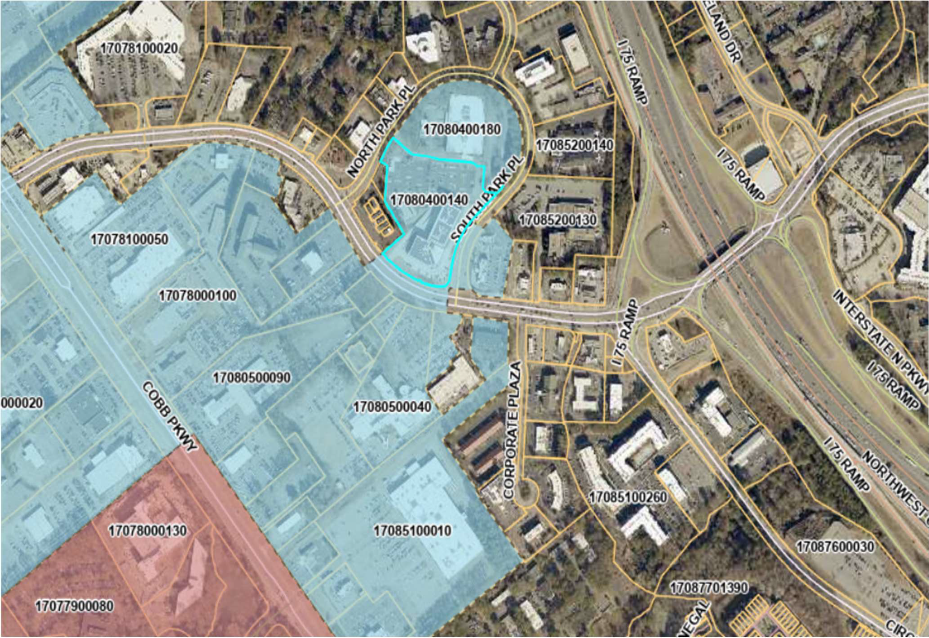


FIGURE 1
SITE LOCATION MAP
Porsche Atlanta Northwest 2501 Windy Hill Road SE Marietta, Georgia

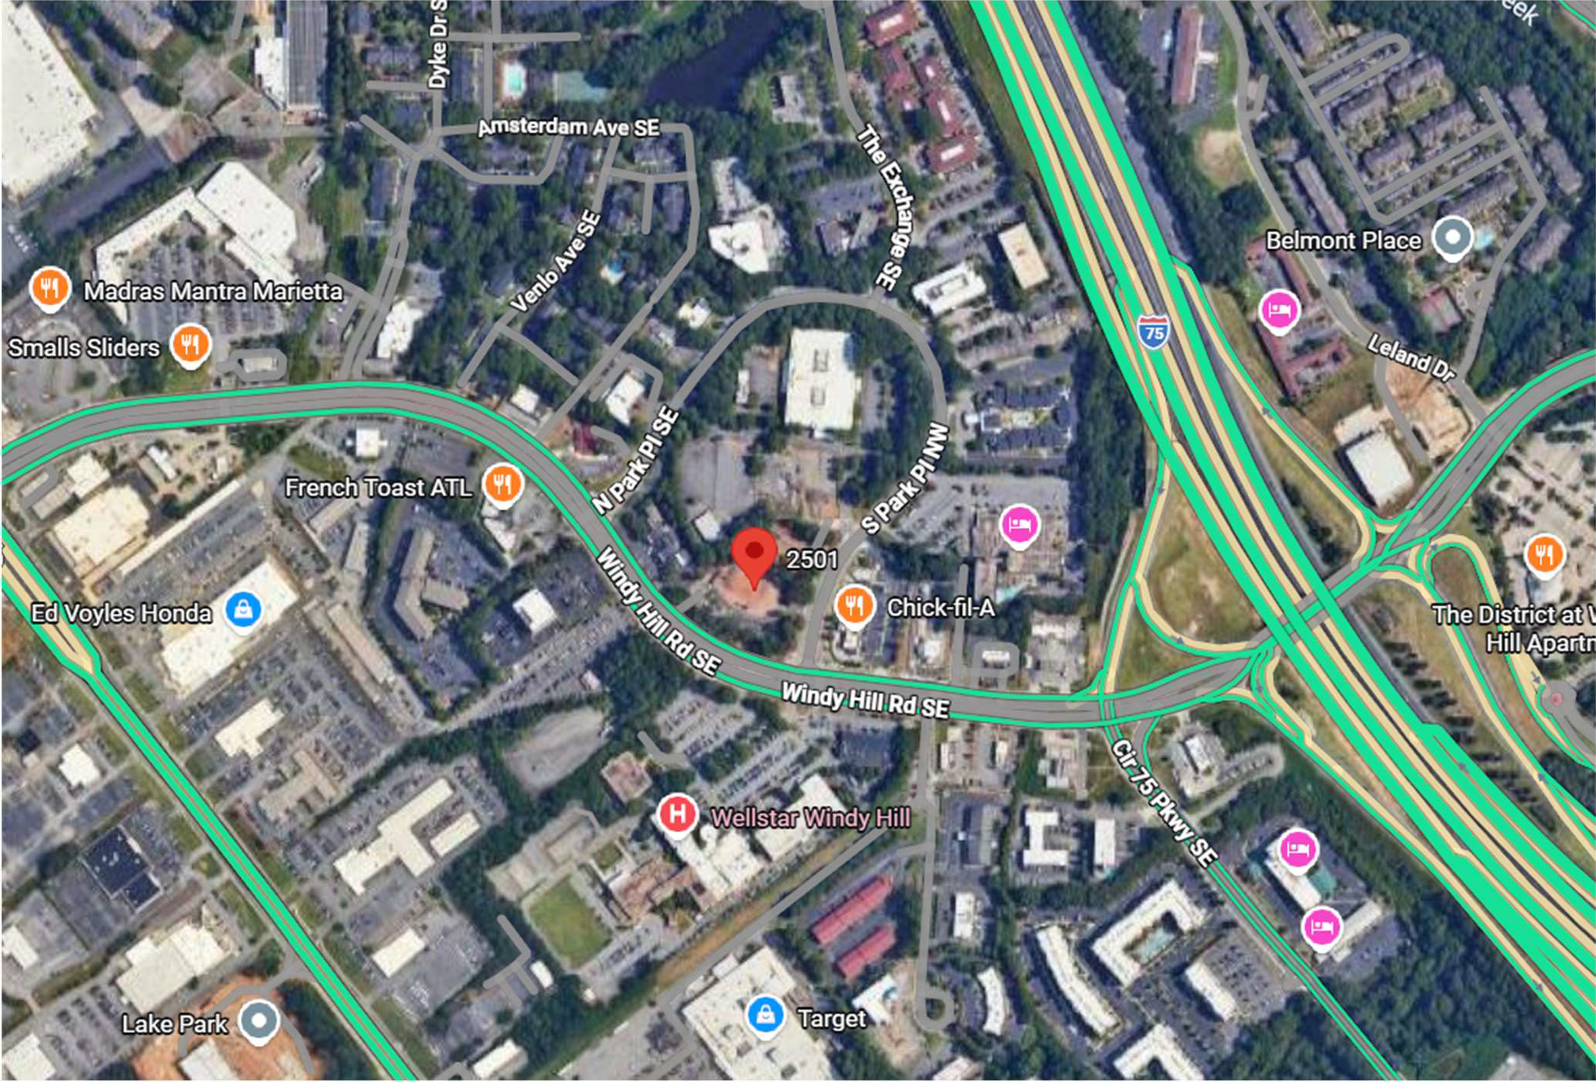

FIGURE 2 SITE PLAN
Porsche Atlanta Northwest 2501 Windy Hill Road SE Marietta, Georgia

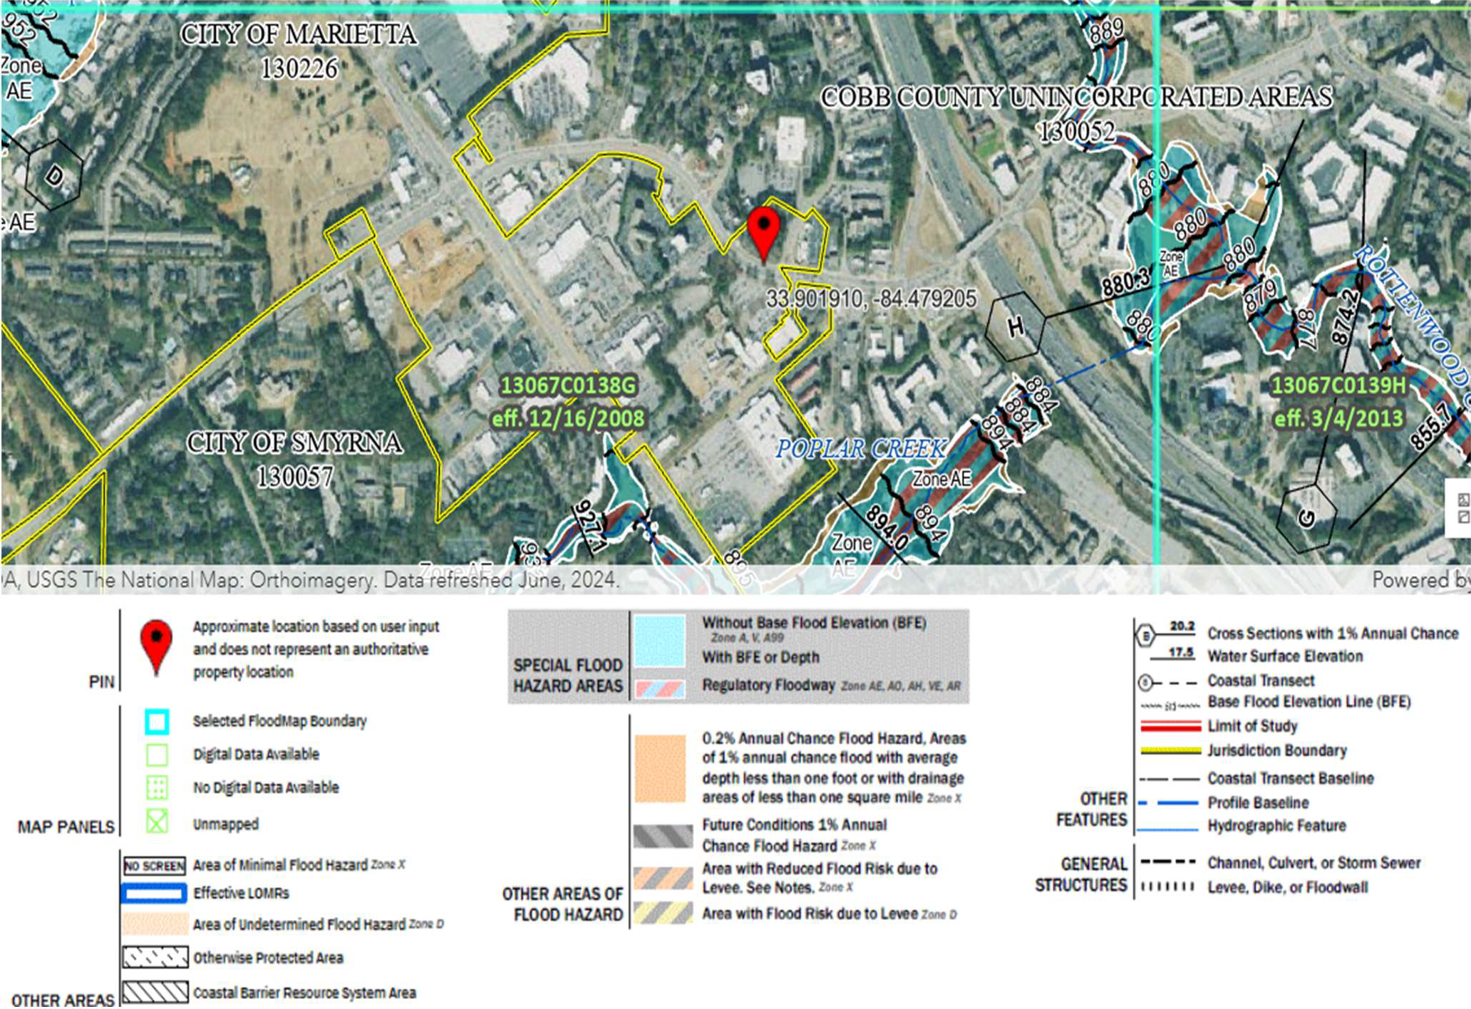

FIGURE 3 FLOOD ZONE MAP
Porsche Atlanta Northwest 2501 Windy Hill Road SE Marietta, Georgia

Tables

Table 1: Immediate Repairs & Long-Term Cost Opinion

Porsche Atlanta Northwest 2501 Windy Hill Road SE Marietta, GA
Year Built: 2010 & 2024 Total Area (SF): 51,996 SF Number of Buildings: 2

Sect. # | Deficiency or Repair Item | Quantity | Unit | Unit Cost | Immediate Needs | Short-Term Needs | Long-Term Needs
3.2.4 | Clean, seal coat, & stripe parking lot and driveways (Year 3) | 14,500 | SY | $5.40 |  |  | $78,300.00
3.2.4 | Clean, seal coat, & stripe parking lot and driveways (Year 8) | 14,500 | SY | $5.40 |  |  | $78,300.00
Units
SY=Square Yards

Table 2: Needs Distribution of Long-Term Needs

Porsche Atlanta Northwest 2501 Windy Hill Road SE Marietta, GA
Year Built: 2010 & 2024 Total Area (SF): 51,996 SF Number of Buildings: 2
Inflation Rate 3.00%
Evaluation Period (years) 10
Sect. # | Description | Avg EUL (YR) | Eff Age (YR) | RUL (YR) | Qty in Eval Period | Unit | Unit Cost | Immediate Needs | YR 1 | YR 2 | YR 3 | YR 4 | YR 5 | YR 6 | YR 7 | YR 8 | YR 9 | YR 10 | Long Term Needs
3.2.4 | Clean, seal coat, & stripe parking lot and driveways (Year 3) | 5 | 2 | 3 | 14,500 | SY | $5.40 |  |  |  | $78,300 |  |  |  |  |  |  |  | $78,300
3.2.4 | Clean, seal coat, & stripe parking lot and driveways (Year 8) | 5 | -3 | 8 | 14,500 | SY | $5.40 |  |  |  |  |  |  |  |  | $78,300 |  |  | $78,300

Units
Uniflated Totals:
$0 $0 $78,300 $0 $0 $0 $0 $78,300 $0 $0 $156,600

SY=Square Yards | Inflation: | 1 | 1.03 | 1.061 | 1.093 | 1.126 | 1.159 | 1.194 | 1.230 | 1.267 | 1.305
 | Inflated Totals: | $0 | $0 | $83,076 | $0 | $0 | $0 | $0 | $96,309 | $0 | $0 | $179,385

Appendix A Photographic Log

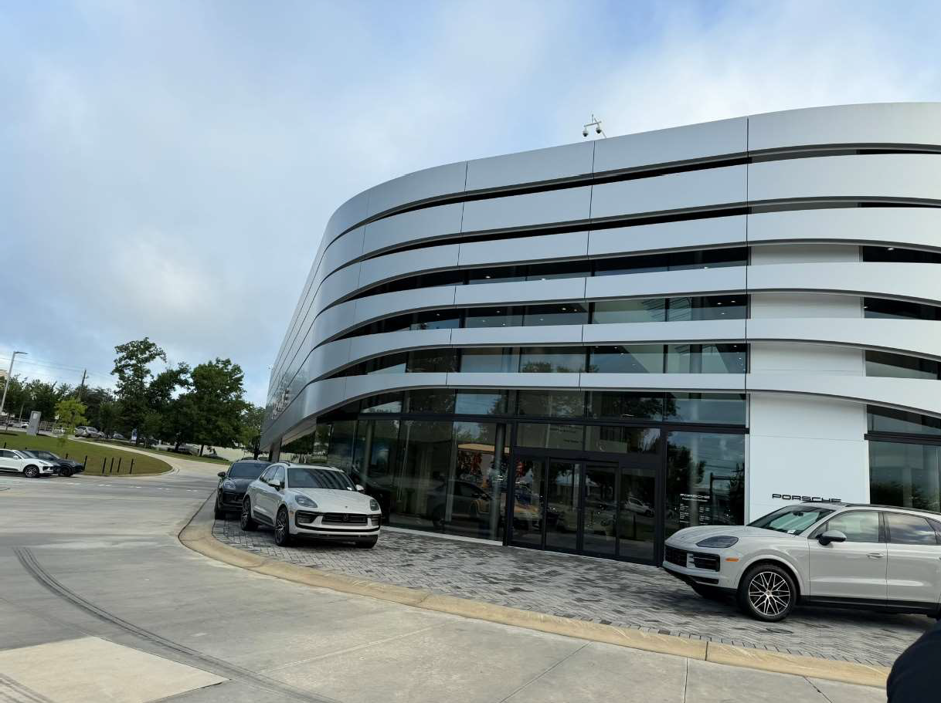
Photograph: 1 | View of the front or southern portion of the dealership
Porsche Atlanta Northwest |  |  | 2501 Windy Road SE  Marietta, GA

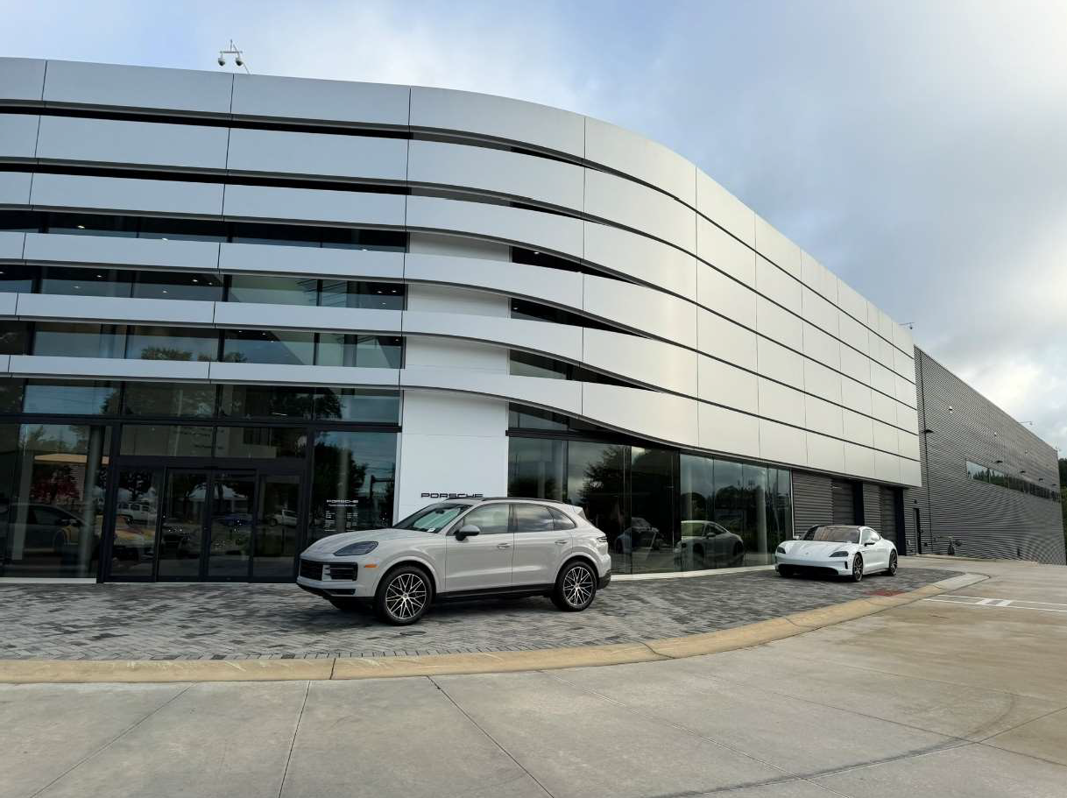
Photograph: 2 | View of the eastern side of dealership
Porsche Atlanta Northwest |  |  | 2501 Windy Road SE  Marietta, GA

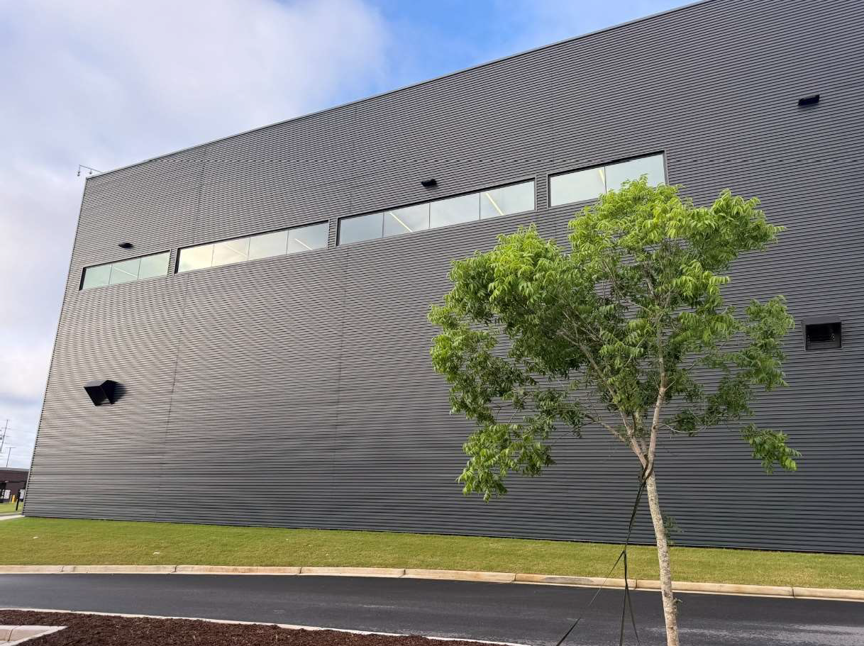
Photograph: 3 | View of rear or northern portion of the dealership building
Porsche Atlanta Northwest |  |  | 2501 Windy Road SE  Marietta, GA

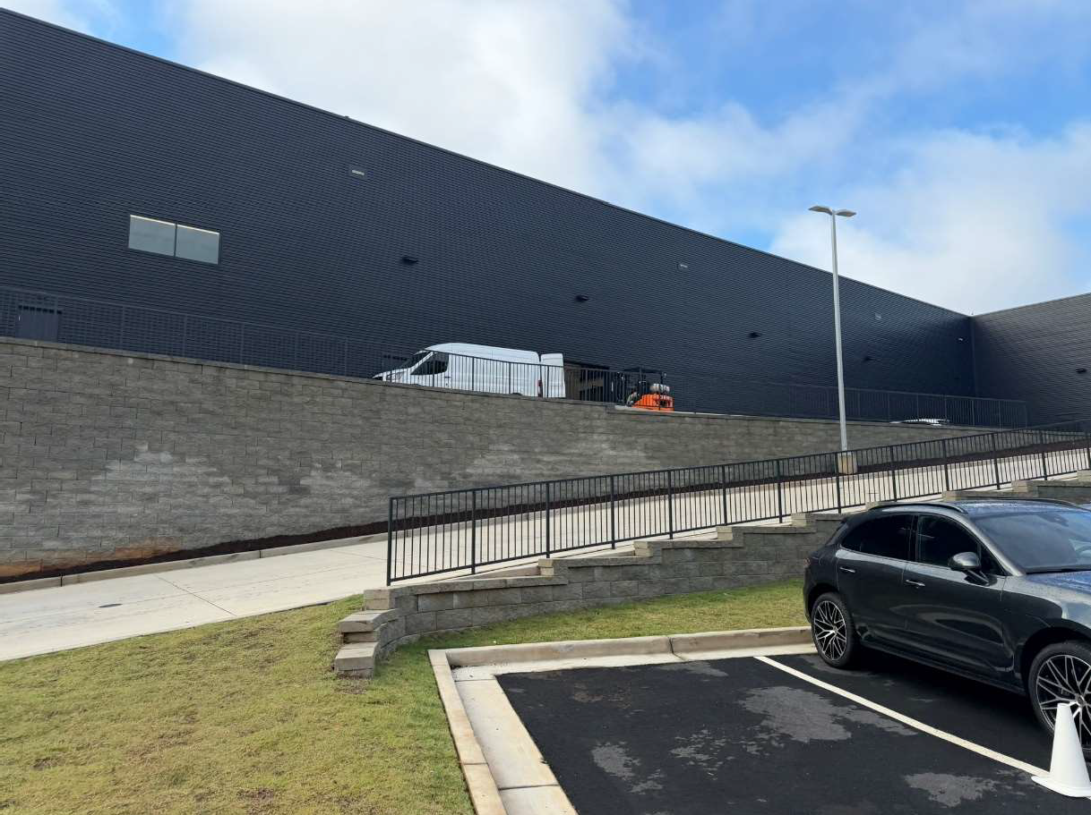
Photograph: 4 | View of western portion of the dealership building
Porsche Atlanta Northwest |  |  | 2501 Windy Road SE  Marietta, GA

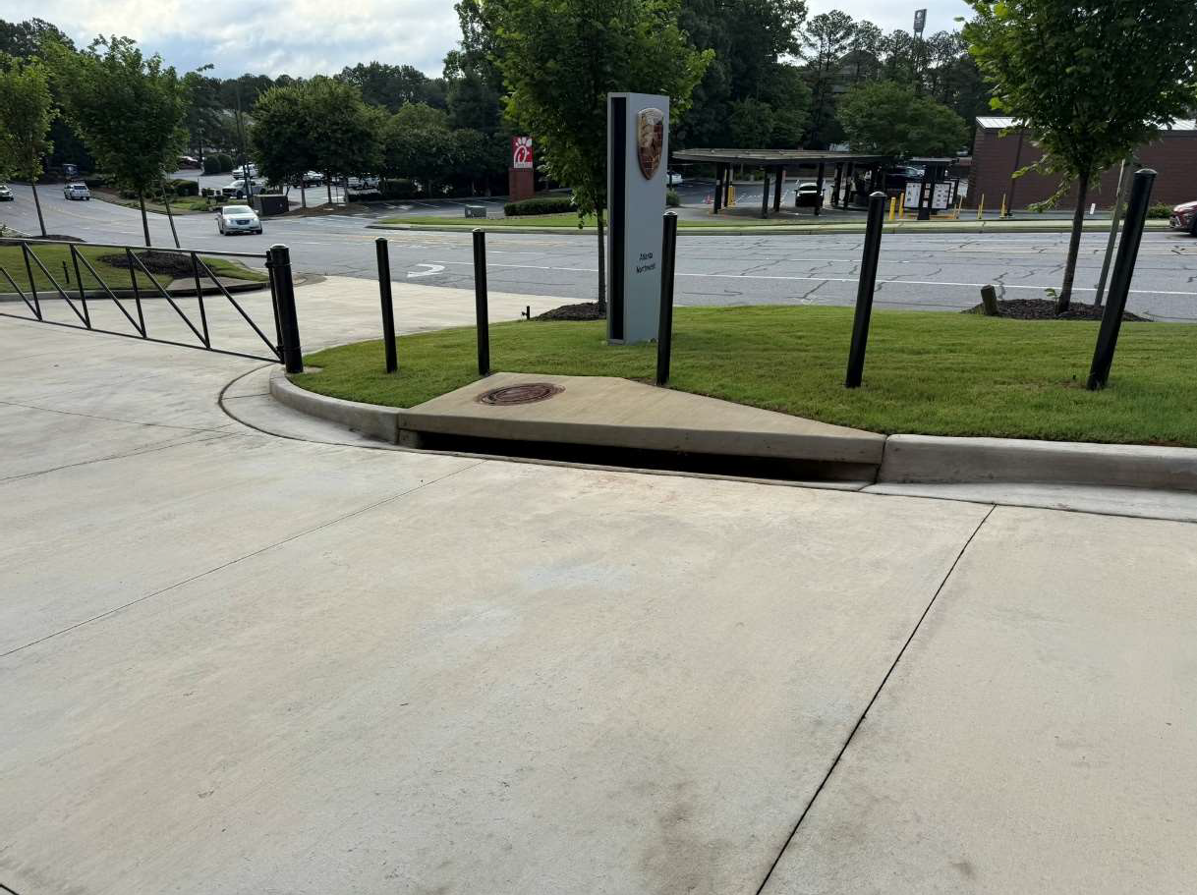
Photograph: 5 | View of curbed gutter on the eastern portion of the dealership
Porsche Atlanta Northwest |  |  | 2501 Windy Road SE  Marietta, GA

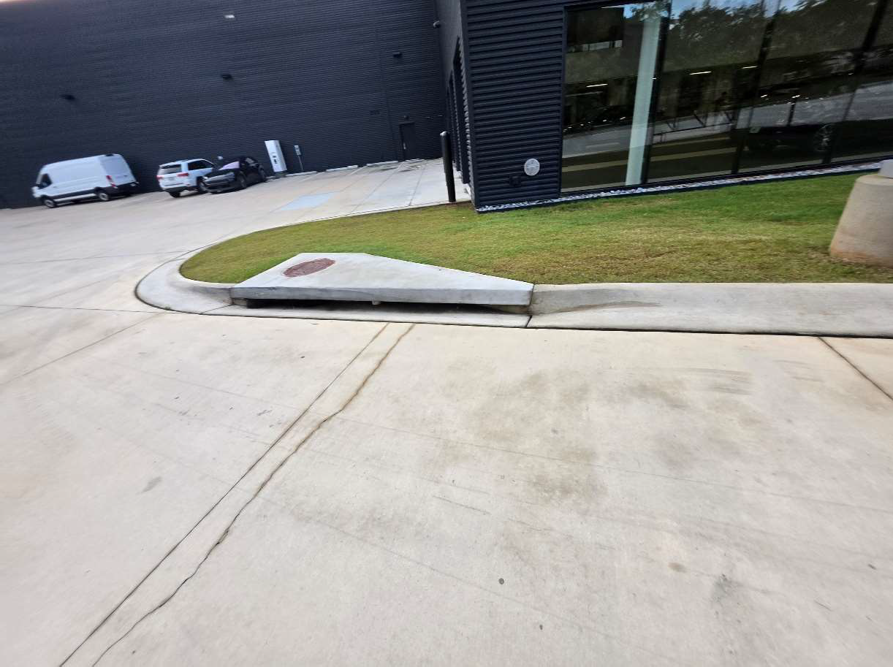
Photograph: 6 | View of curbed gutter on the western portion of the dealership property
Porsche Atlanta Northwest |  |  | 2501 Windy Road SE  Marietta, GA

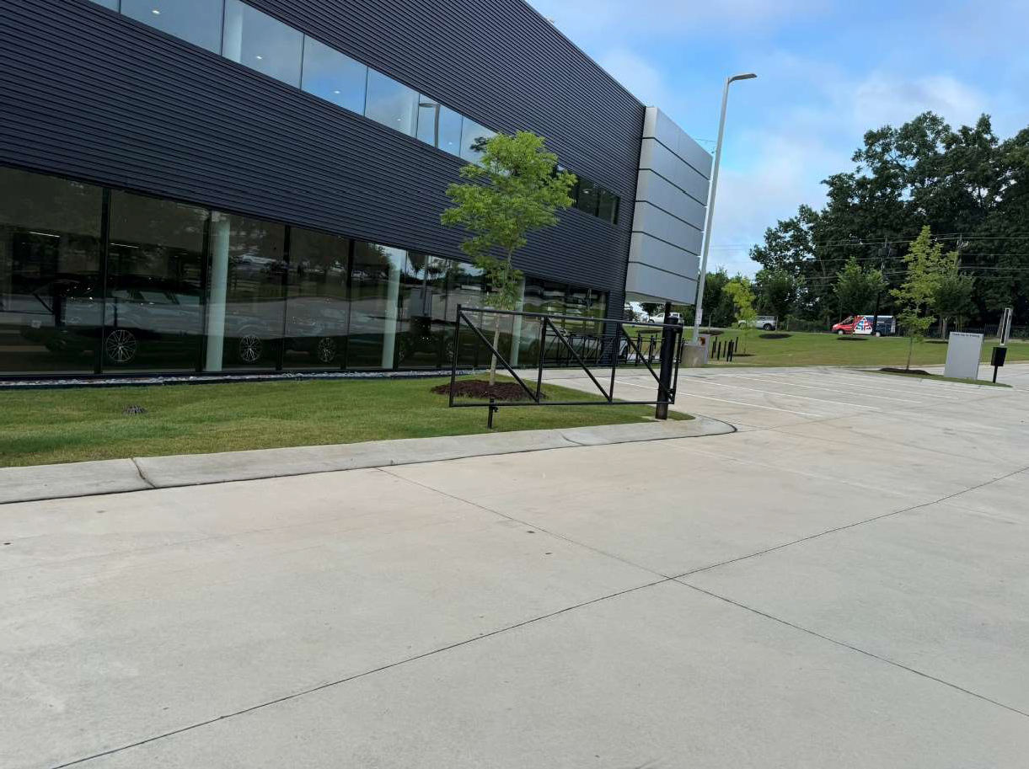
Photograph: 7 | View of controlled access to dealership from Windy Hill Road SE
Porsche Atlanta Northwest |  |  | 2501 Windy Road SE  Marietta, GA

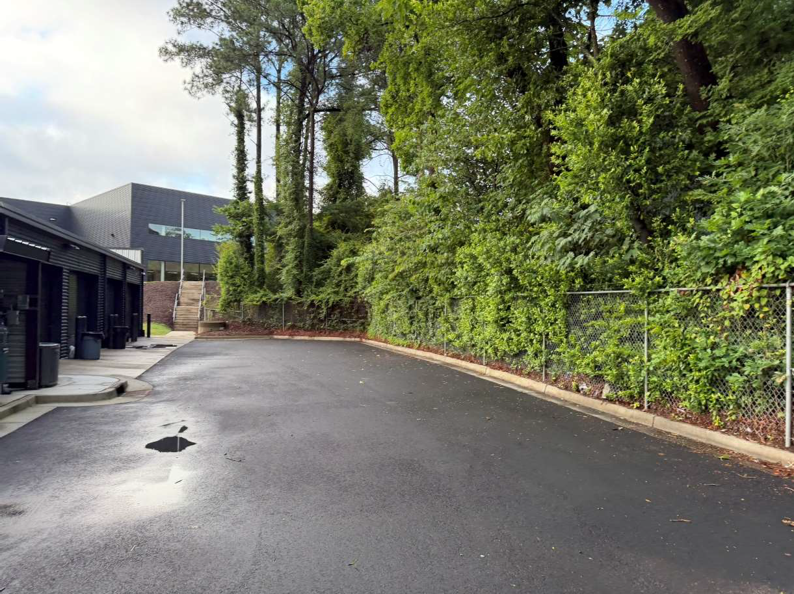
Photograph: 8 | View of asphalt on rear or western portion of the detail building
Porsche Atlanta Northwest |  |  | 2501 Windy Road SE  Marietta, GA

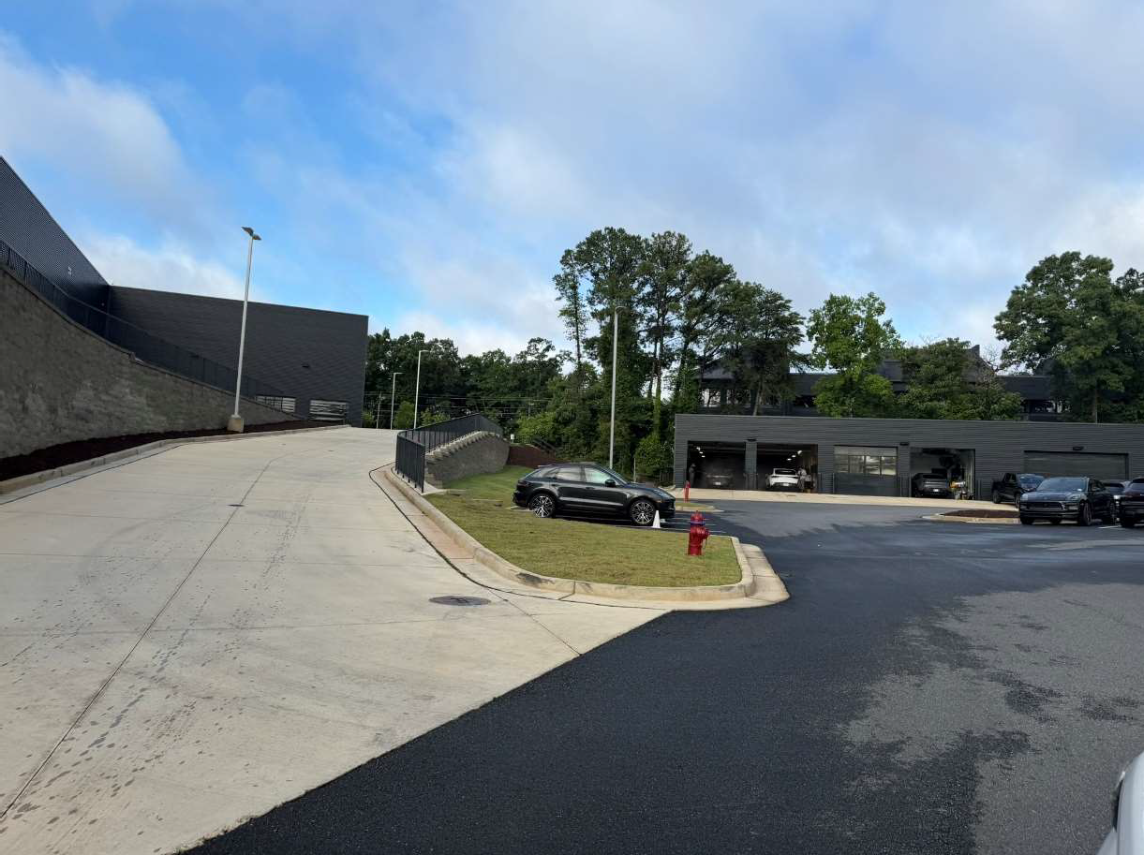
Photograph: 9 | View of asphalt and concrete on western portion of dealership building
Porsche Atlanta Northwest |  |  | 2501 Windy Road SE  Marietta, GA

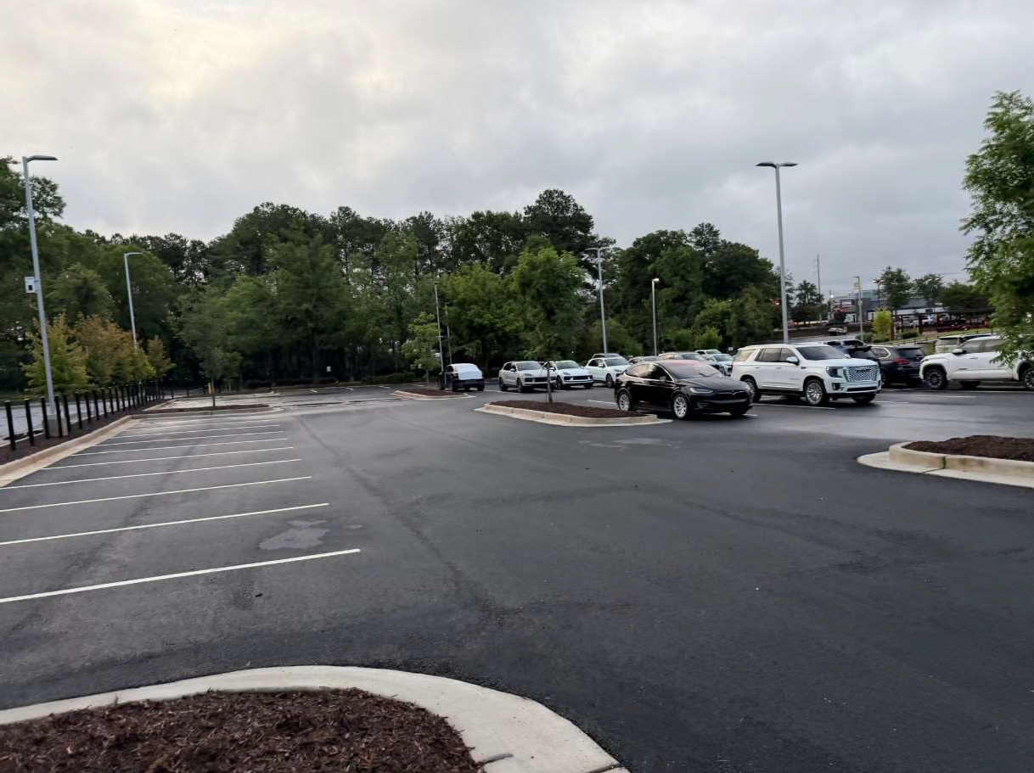
Photograph: 10 | View of asphalt in good condition in the rear or northern portion of the dealership property
Porsche Atlanta Northwest |  |  | 2501 Windy Road SE  Marietta, GA

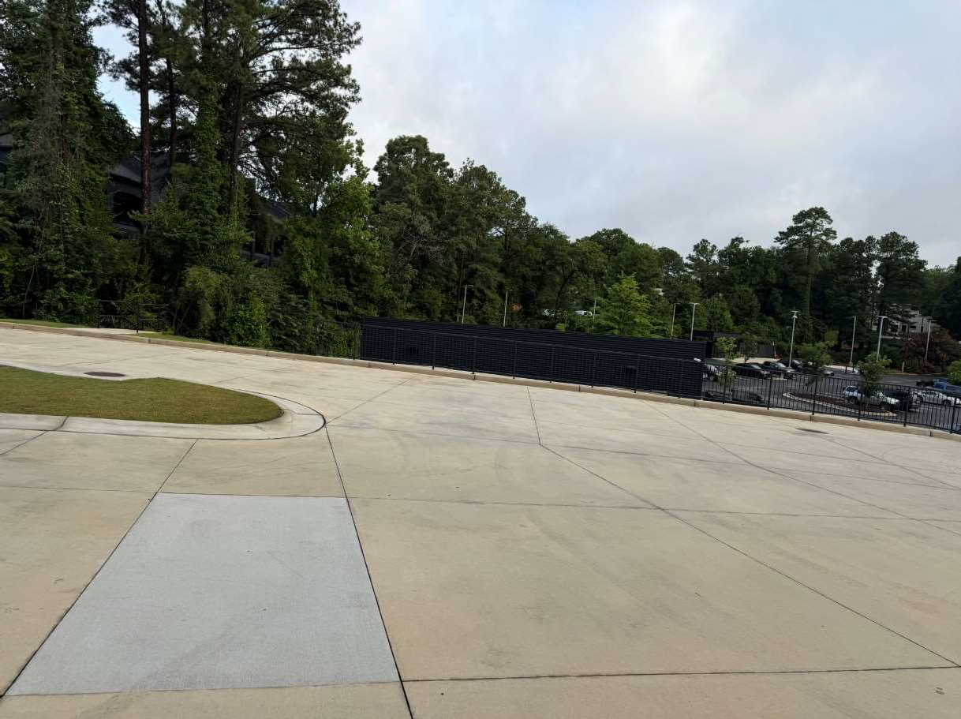
Photograph: 11 | View of concrete drive on western portion of the dealership property
Porsche Atlanta Northwest |  |  | 2501 Windy Road SE  Marietta, GA

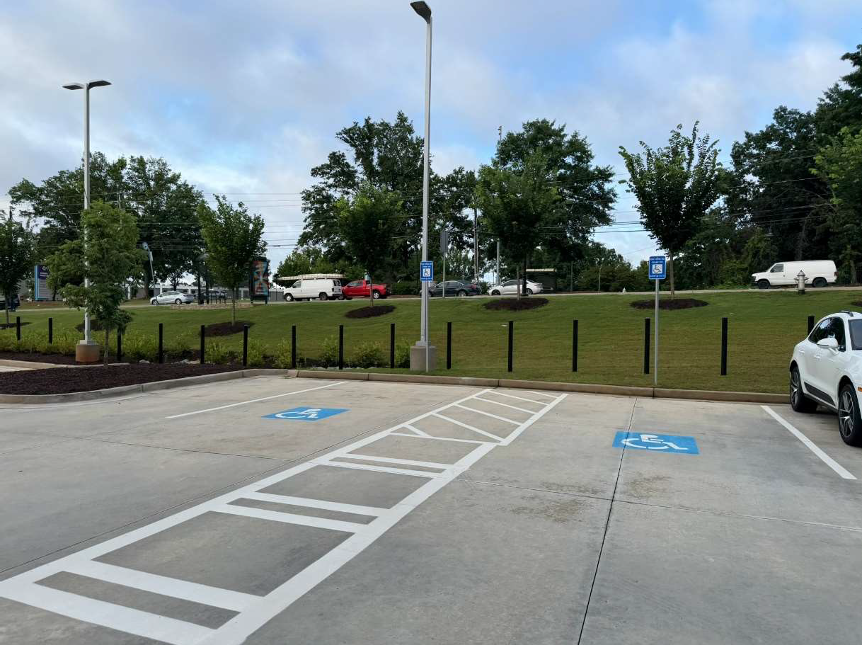
Photograph: 12 | View of handicap parking spaces in front of dealership
Porsche Atlanta Northwest |  |  | 2501 Windy Road SE  Marietta, GA

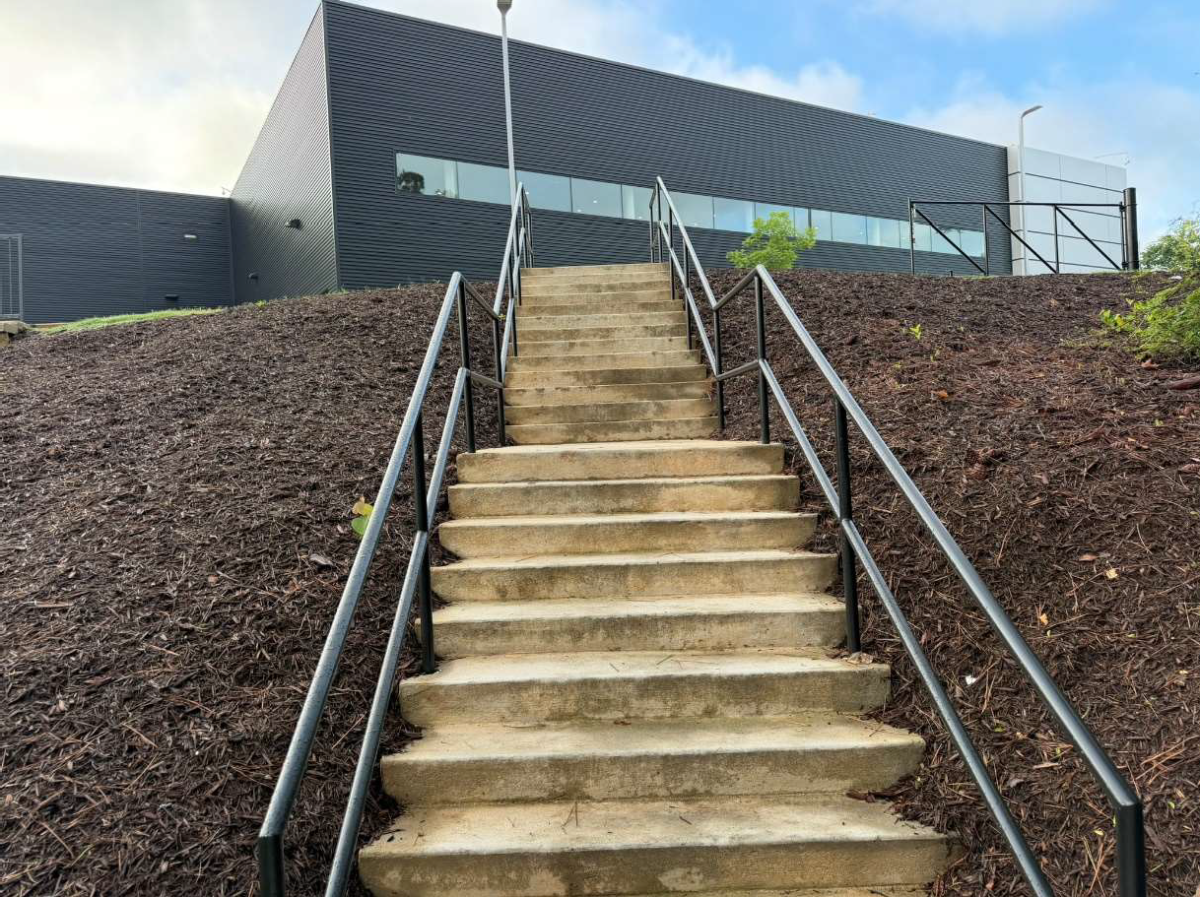
Photograph: 13 | View of concrete steps linking the detail shop and dealership building on the western portion of property
Porsche Atlanta Northwest |  |  | 2501 Windy Road SE  Marietta, GA

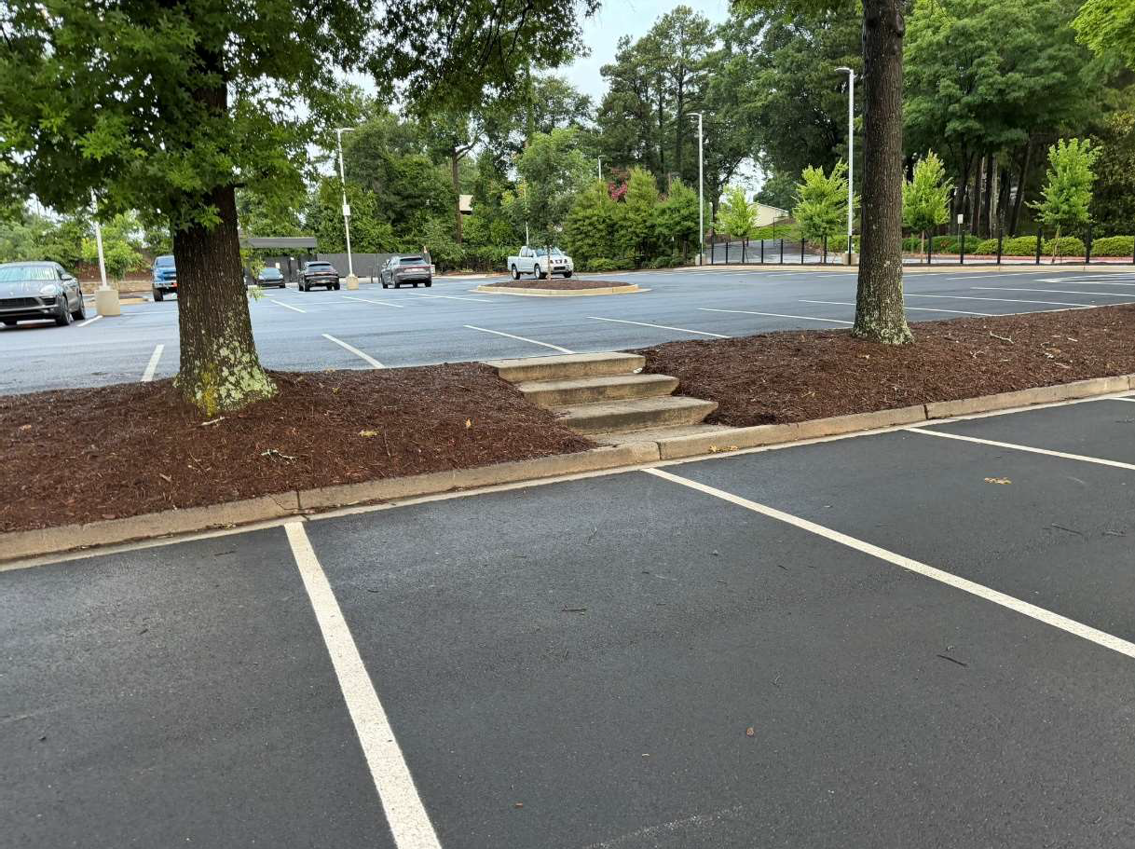
Photograph: 14 | View of concrete steps on northern portion of the dealership property
Porsche Atlanta Northwest |  |  | 2501 Windy Road SE  Marietta, GA

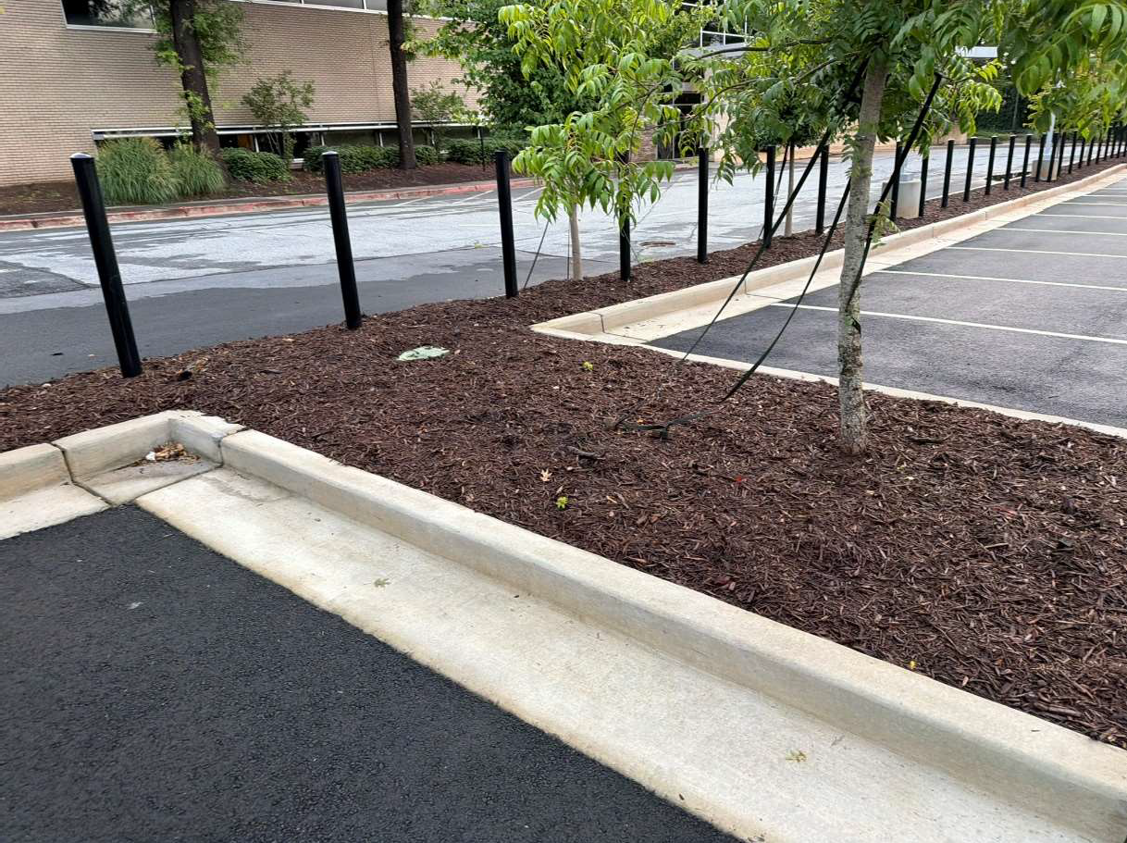
Photograph: 15 | View of a typical landscaped island on the dealership property
Porsche Atlanta Northwest |  |  | 2501 Windy Road SE  Marietta, GA

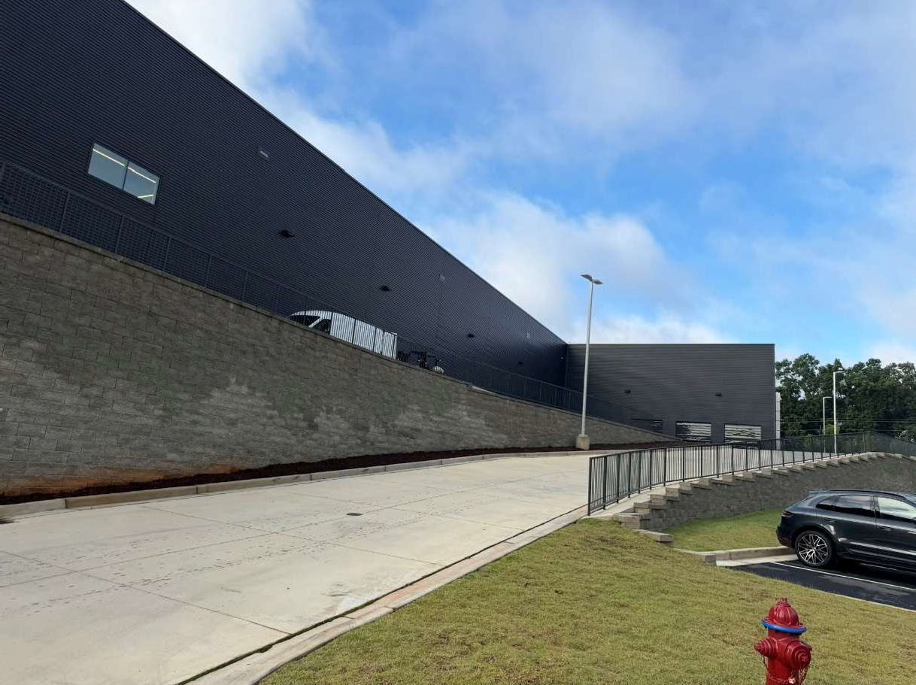
Photograph: 16 | View of retaining wall on western portion of the dealership property
Porsche Atlanta Northwest |  |  | 2501 Windy Road SE  Marietta, GA

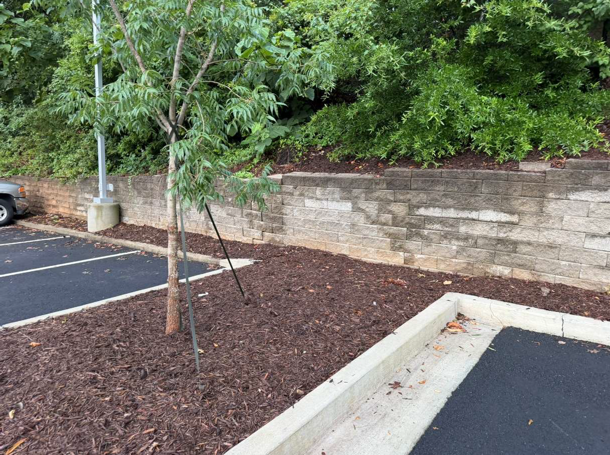
Photograph: 17 | View of retaining wall on western portion of the parking lot
Porsche Atlanta Northwest |  |  | 2501 Windy Road SE  Marietta, GA

Photograph: 18 | View of monument signage along Windy Hill Road SE
Porsche Atlanta Northwest |  |  | 2501 Windy Road SE  Marietta, GA

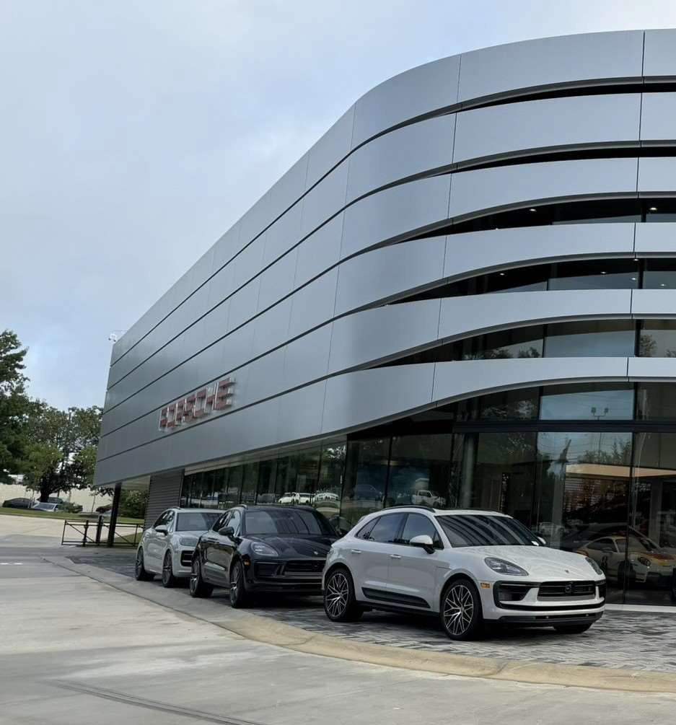
Photograph: 19 | View of building mounted signage on the dealership
Porsche Atlanta Northwest |  |  | 2501 Windy Road SE  Marietta, GA

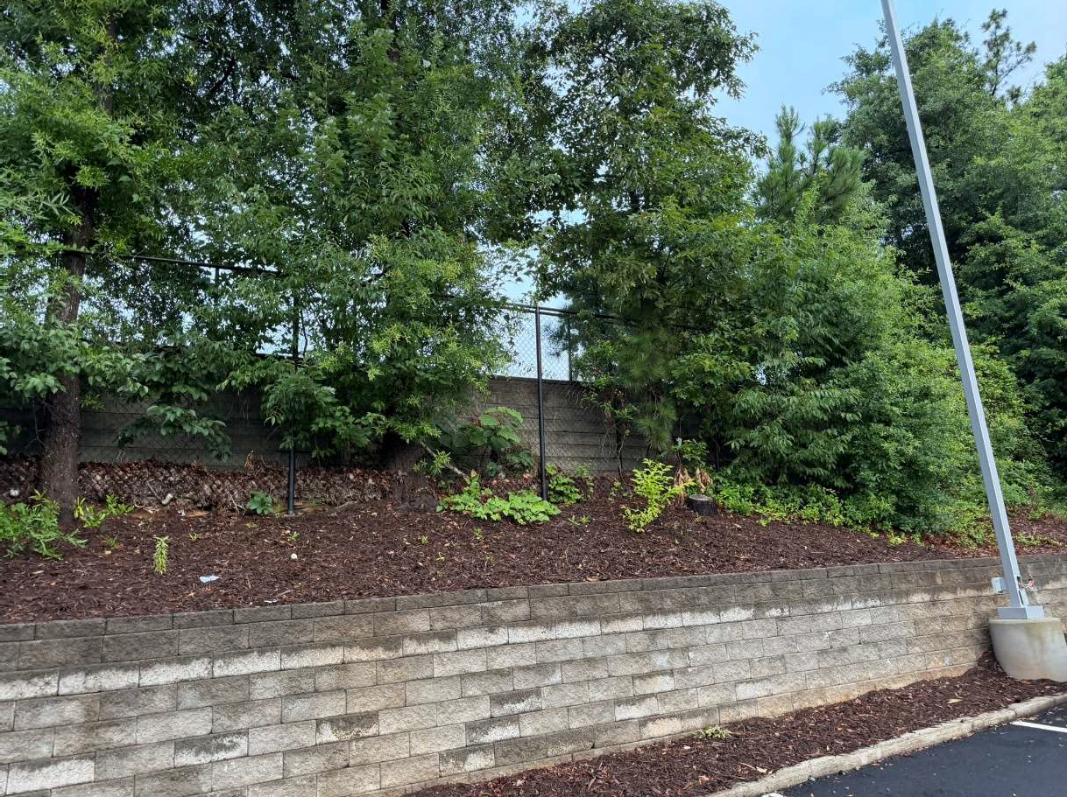
Photograph: 20 | View of Chain-link fence located on top of the retaining wall on the western portion of the dealership property
Porsche Atlanta Northwest |  |  | 2501 Windy Road SE  Marietta, GA

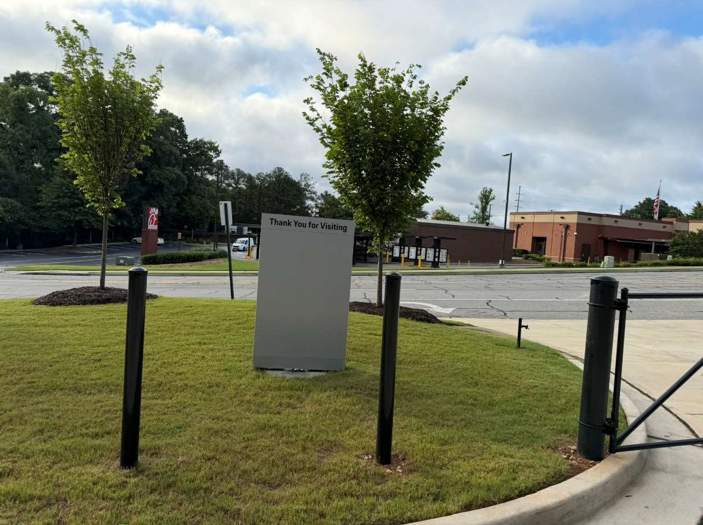
Photograph: 21 | View of bollards and a swinging pole gate at the property entrance from South Park Place
Porsche Atlanta Northwest |  |  | 2501 Windy Road SE  Marietta, GA

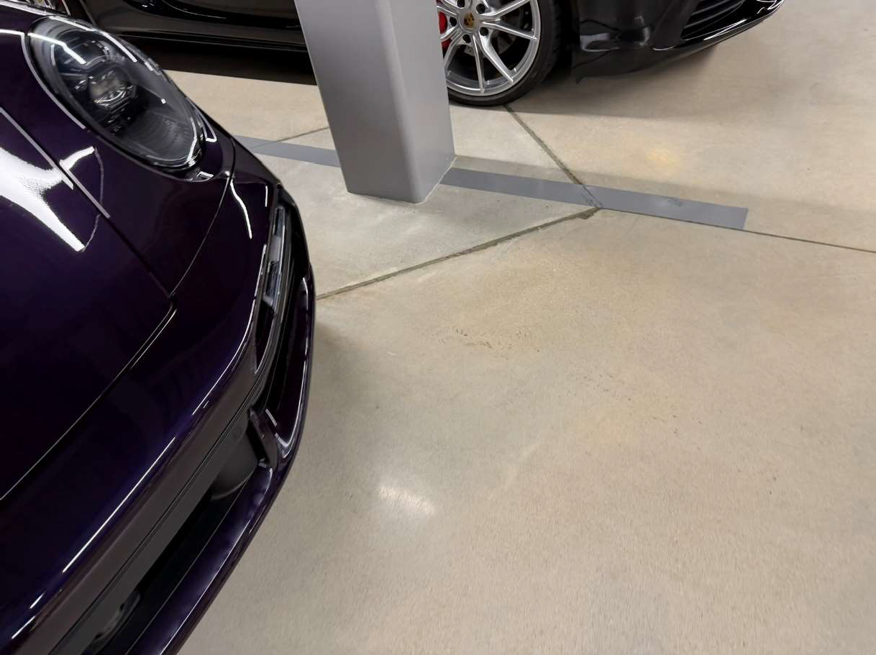
Photograph: 22 | View of a support column in the dealership building
Porsche Atlanta Northwest |  |  | 2501 Windy Road SE  Marietta, GA

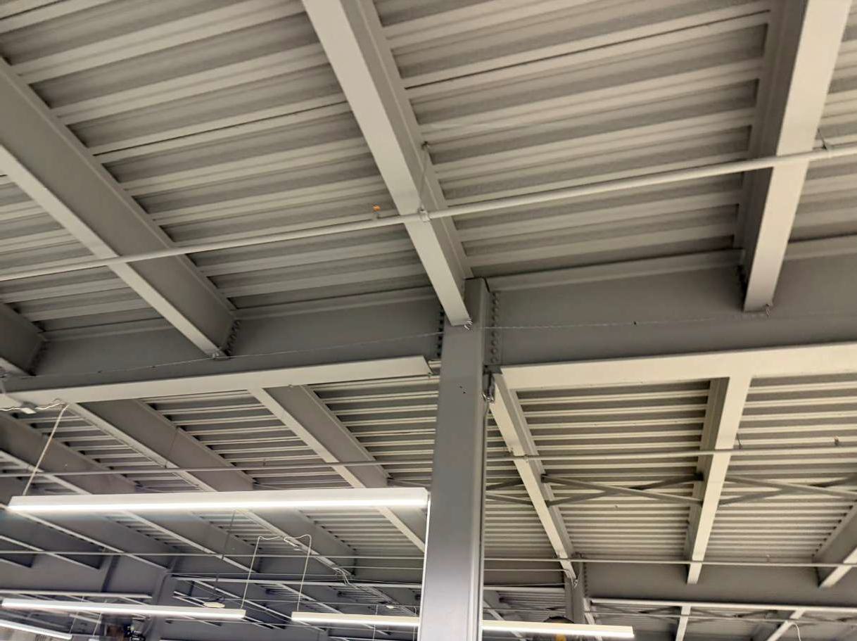
Photograph: 23 | View of the structural components of the dealership building
Porsche Atlanta Northwest |  |  | 2501 Windy Road SE  Marietta, GA

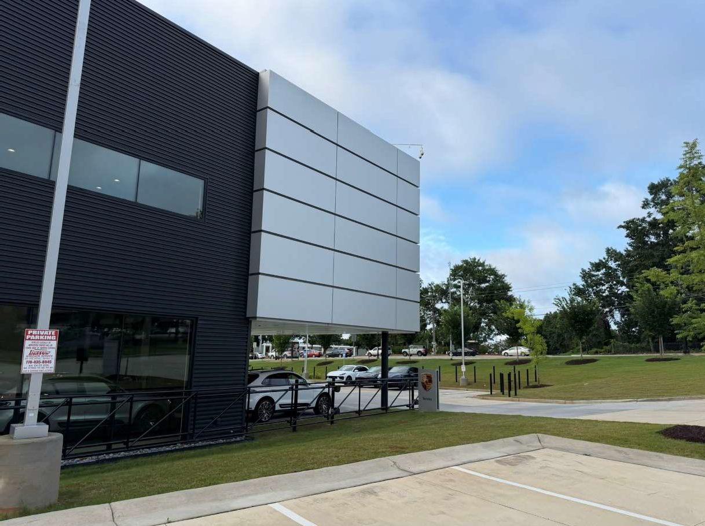
Photograph: 24 | View of exterior finishes w/ smooth decorative metal panels and corrugated metal wall panels on dealership building
Porsche Atlanta Northwest |  |  | 2501 Windy Road SE  Marietta, GA

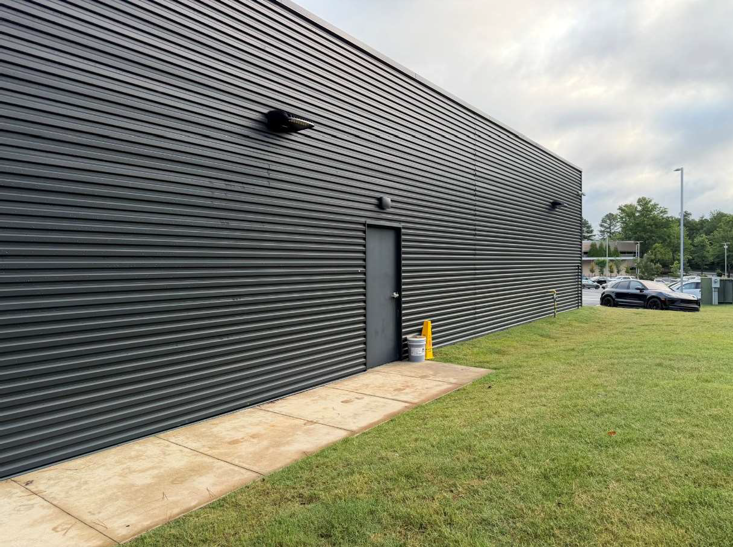
Photograph: 25 | View of corrugated metal panels on detail building
Porsche Atlanta Northwest |  |  | 2501 Windy Road SE  Marietta, GA

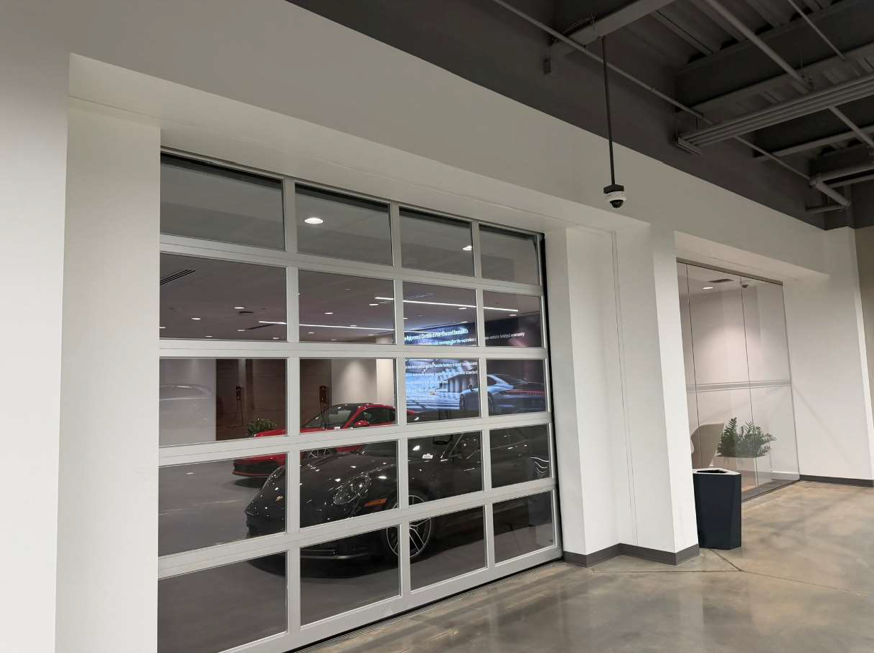
Photograph: 26 | View of a roll-up door in retail area of the dealership
Porsche Atlanta Northwest |  |  | 2501 Windy Road SE  Marietta, GA

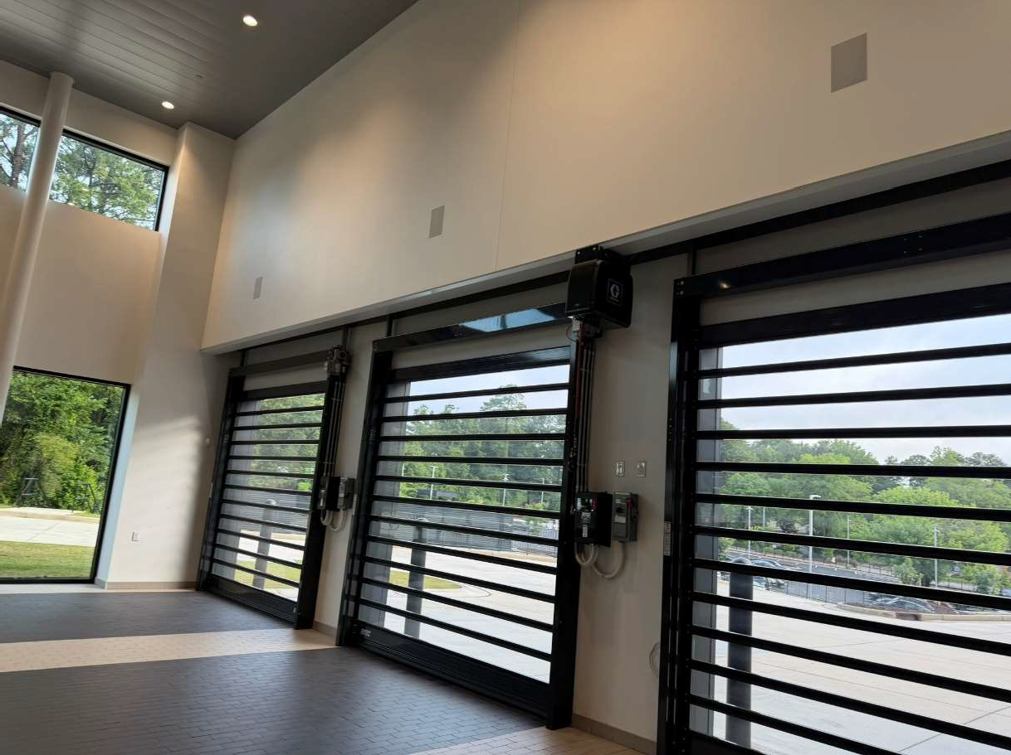
Photograph: 27 | View of automatic Rytech roll-up doors in service drive of dealership building
Porsche Atlanta Northwest |  |  | 2501 Windy Road SE  Marietta, GA

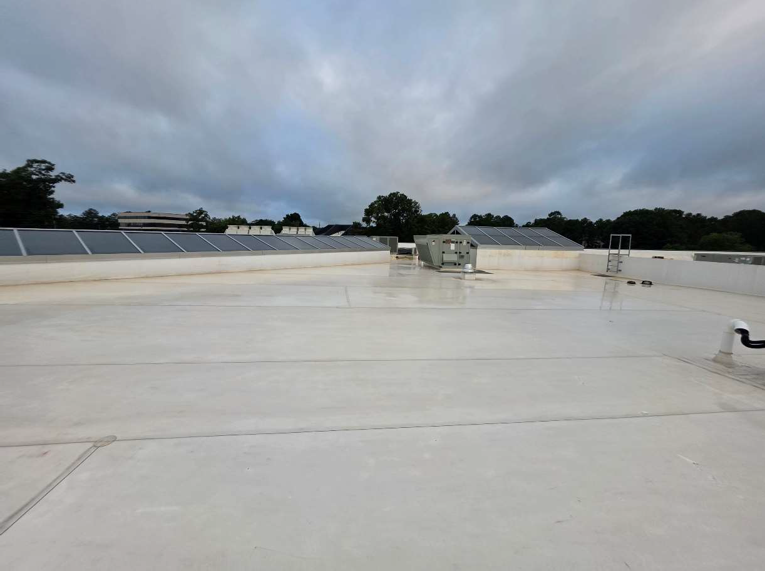
Photograph: 28 | View of the TPO roof on the dealership building
Porsche Atlanta Northwest |  |  | 2501 Windy Road SE  Marietta, GA

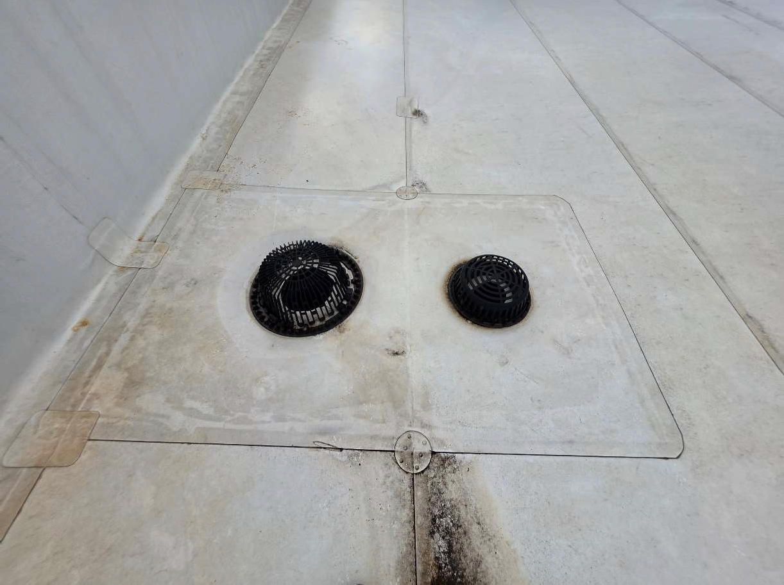
Photograph: 29 | View of the TPO roof and associated drains on the dealership building
Porsche Atlanta Northwest |  |  | 2501 Windy Road SE  Marietta, GA

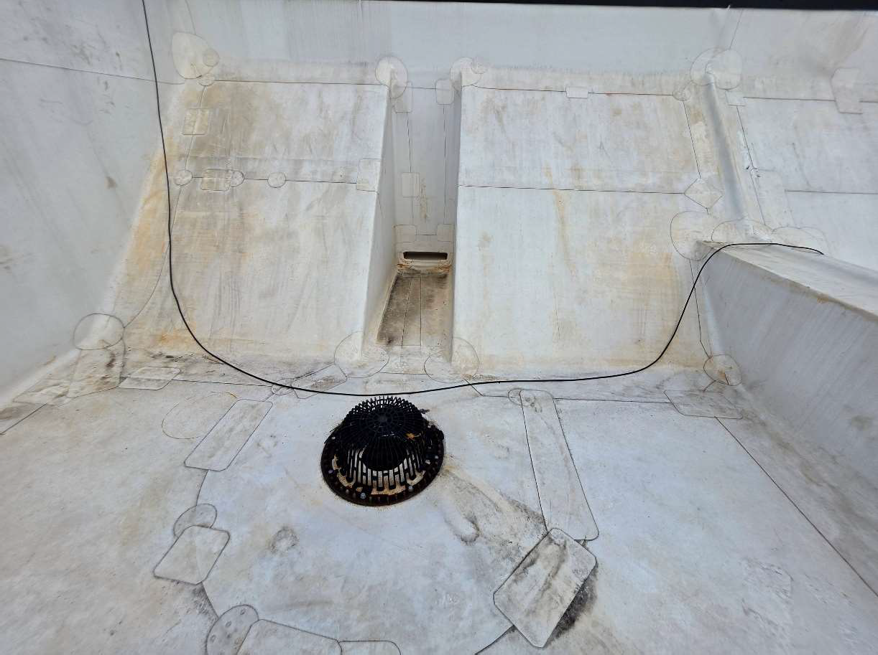
Photograph: 30 | View of a scupper drain on dealership building
Porsche Atlanta Northwest |  |  | 2501 Windy Road SE  Marietta, GA

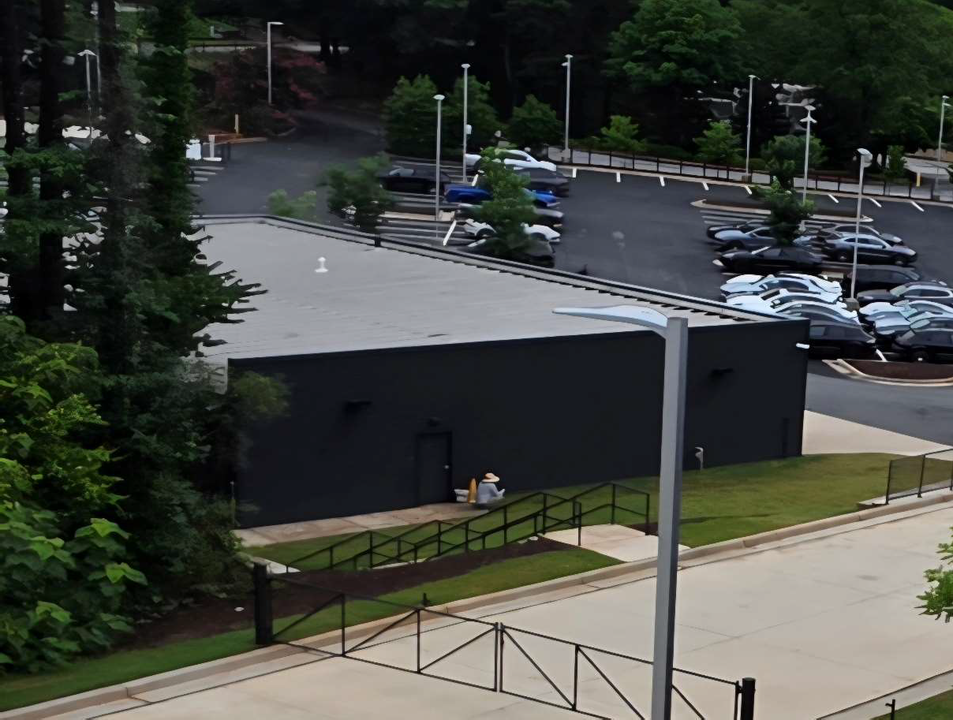
Photograph: 31 | View of metal standing seam roof system on detail building
Porsche Atlanta Northwest |  |  | 2501 Windy Road SE  Marietta, GA

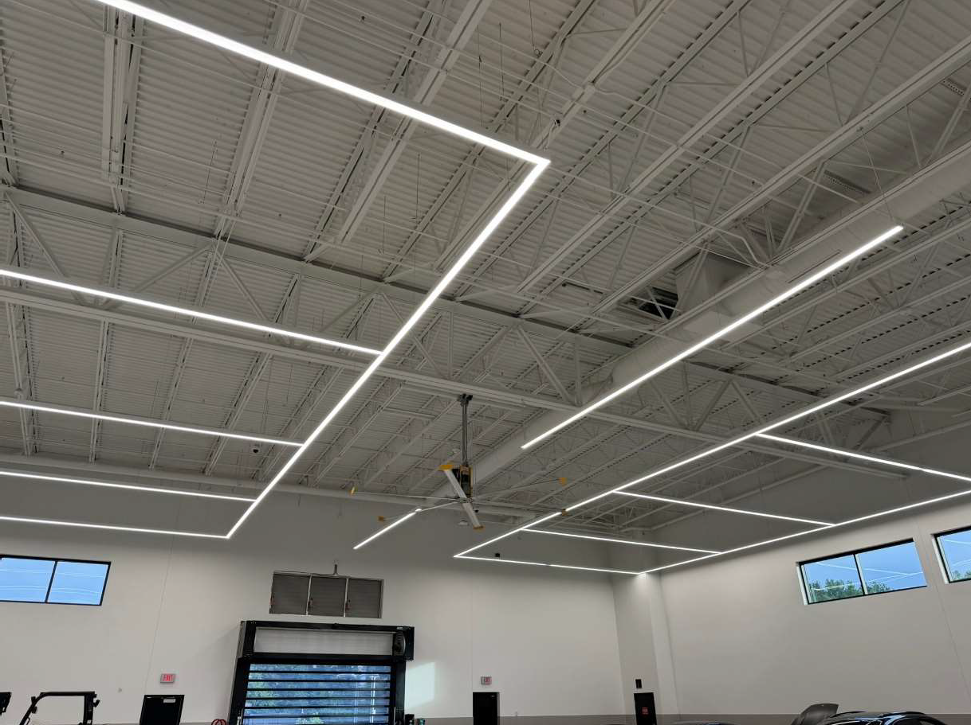
Photograph: 32 | View of a 12-foot Big-Ass fan located in service lane
Porsche Atlanta Northwest |  |  | 2501 Windy Road SE  Marietta, GA

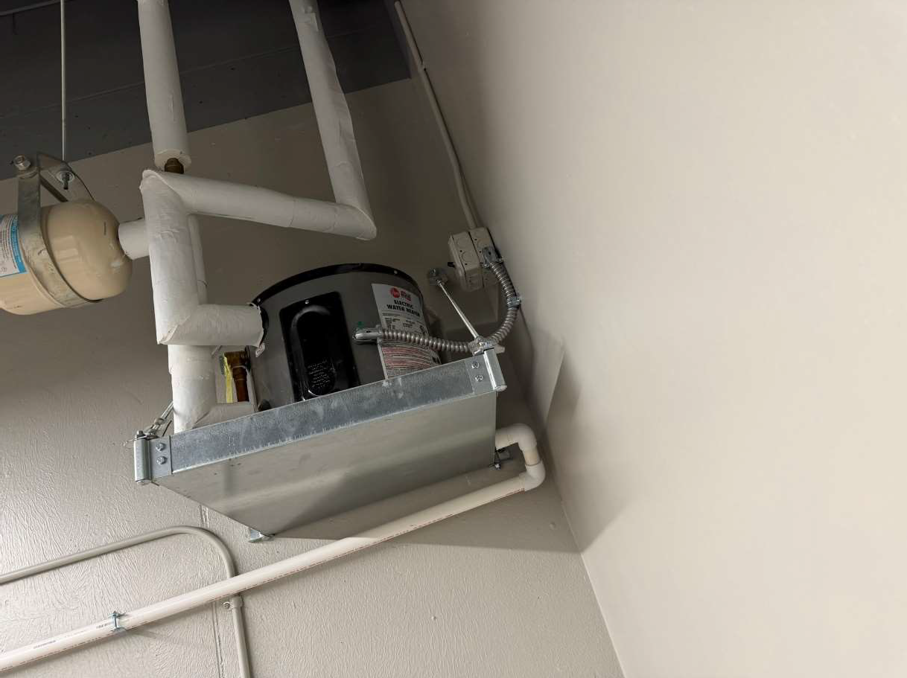
Photograph: 33 | View of an electric water heater located on the 1st floor
Porsche Atlanta Northwest |  |  | 2501 Windy Road SE  Marietta, GA

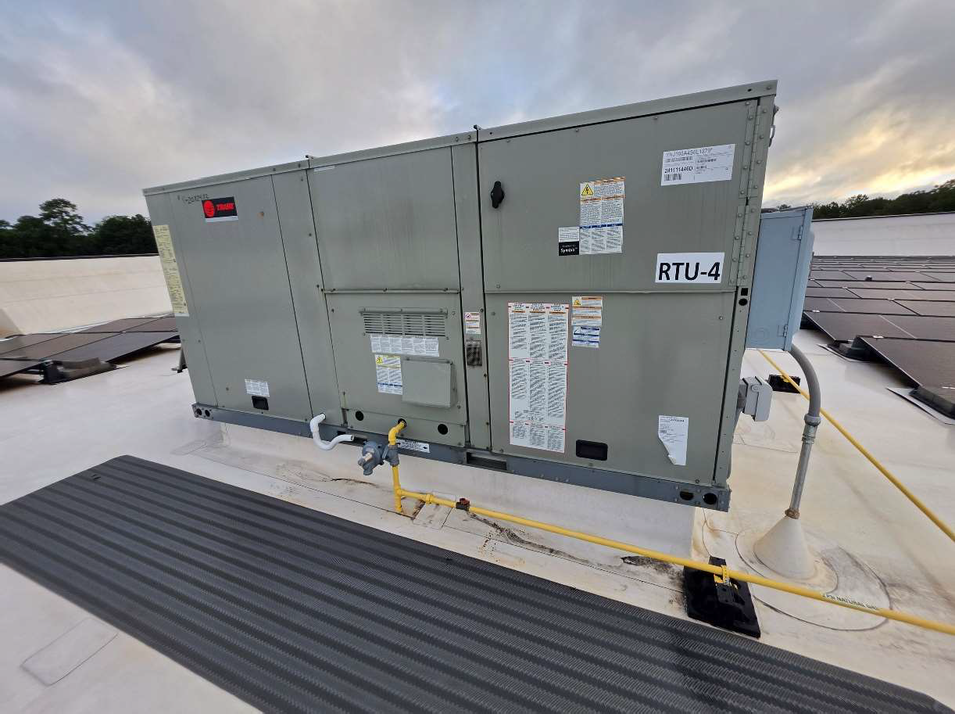
Photograph: 34 | View of a typical roof top unit on dealership building
Porsche Atlanta Northwest |  |  | 2501 Windy Road SE  Marietta, GA

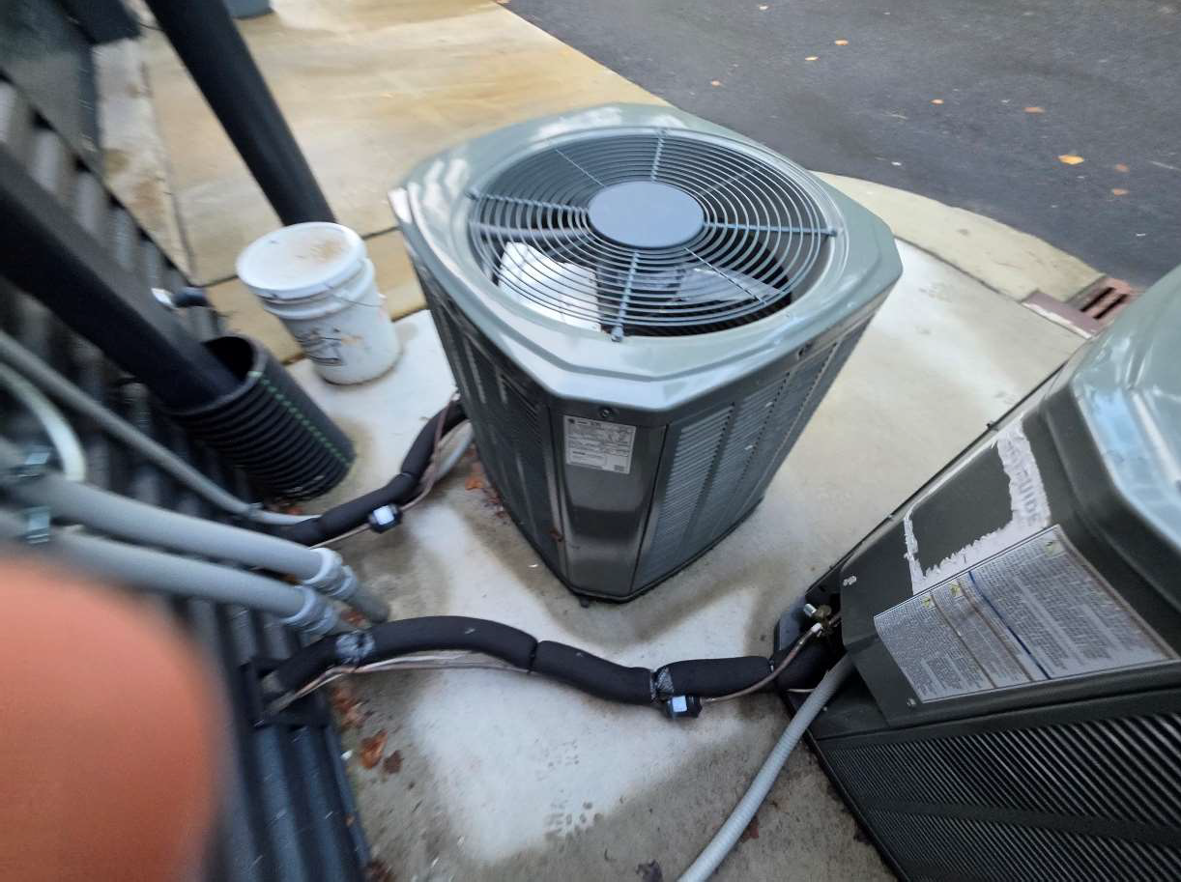
Photograph: 35 | View of split units for the detail building
Porsche Atlanta Northwest |  |  | 2501 Windy Road SE  Marietta, GA

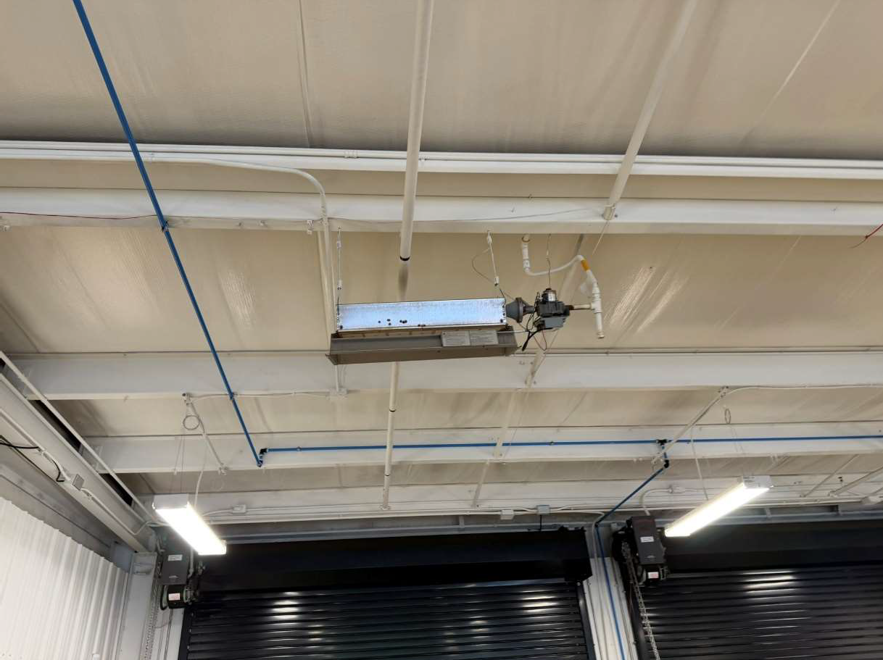
Photograph: 36 | View of ceiling mounted heater located in the service area
Porsche Atlanta Northwest |  |  | 2501 Windy Road SE  Marietta, GA

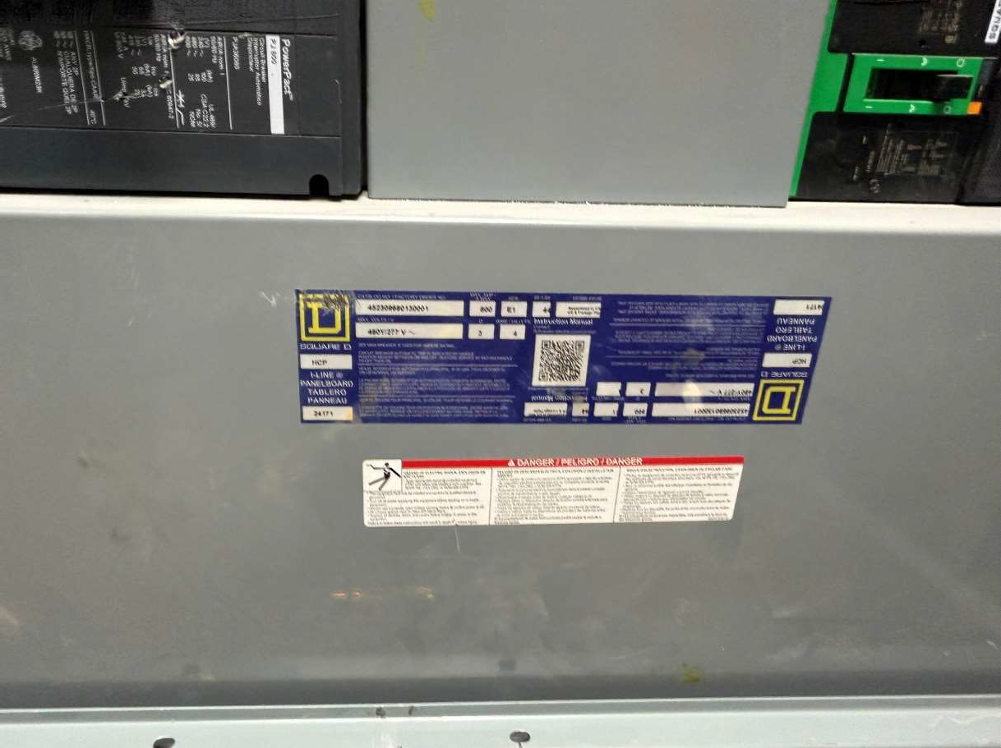
Photograph: 37 | View of the electrical disconnect in the electrical room
Porsche Atlanta Northwest |  |  | 2501 Windy Road SE  Marietta, GA

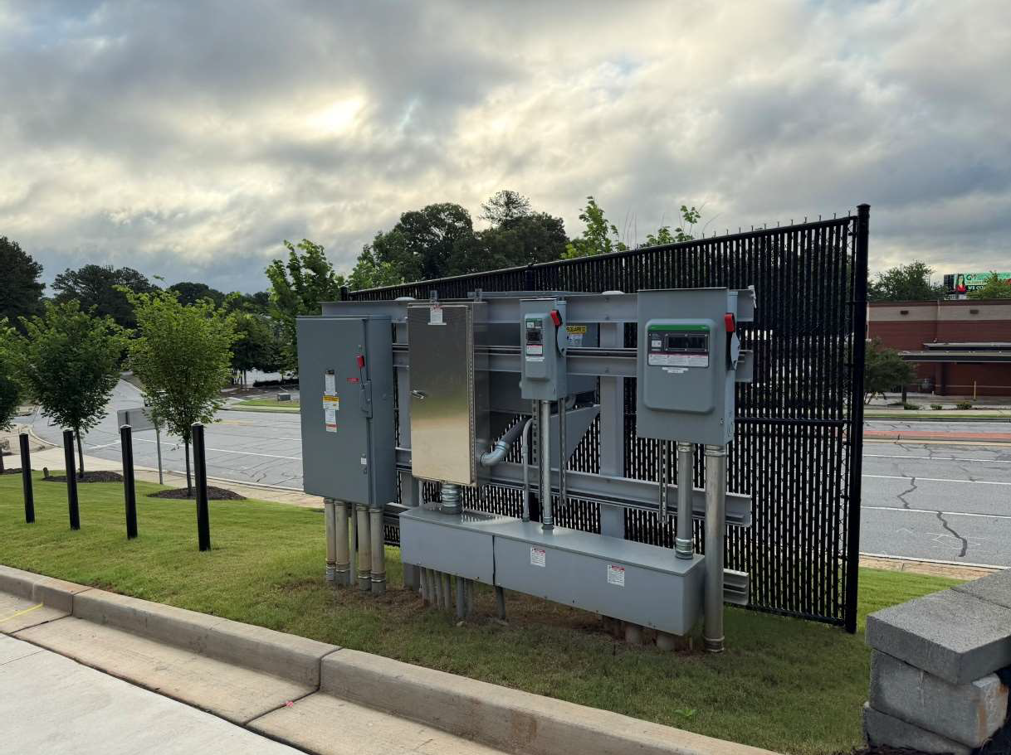
Photograph: 38 | View of the exterior electrical disconnect panels
Porsche Atlanta Northwest |  |  | 2501 Windy Road SE  Marietta, GA

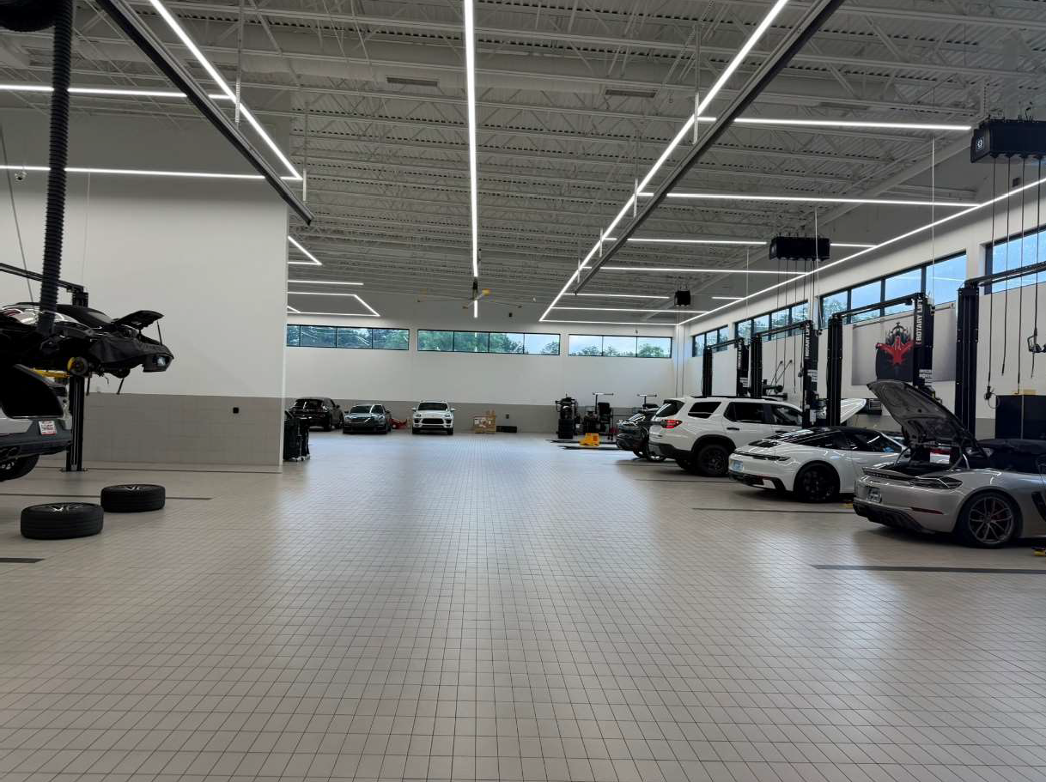
Photograph: 39 | View of LED lighting located in the service area
Porsche Atlanta Northwest |  |  | 2501 Windy Road SE  Marietta, GA

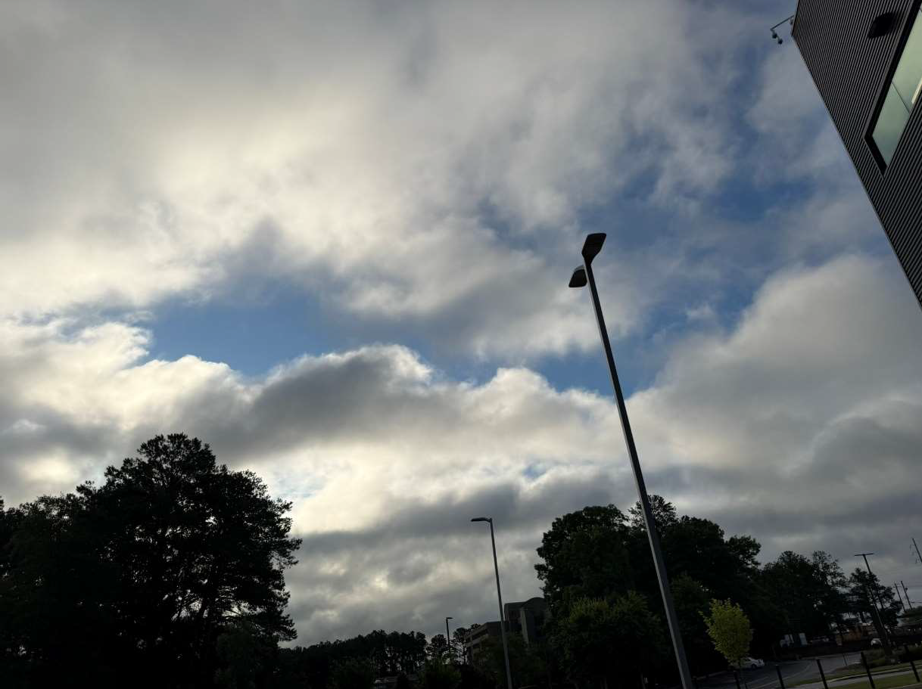
Photograph: 40 | View of a typical pole mounted LED light fixture in the parking lots
Porsche Atlanta Northwest |  |  | 2501 Windy Road SE  Marietta, GA

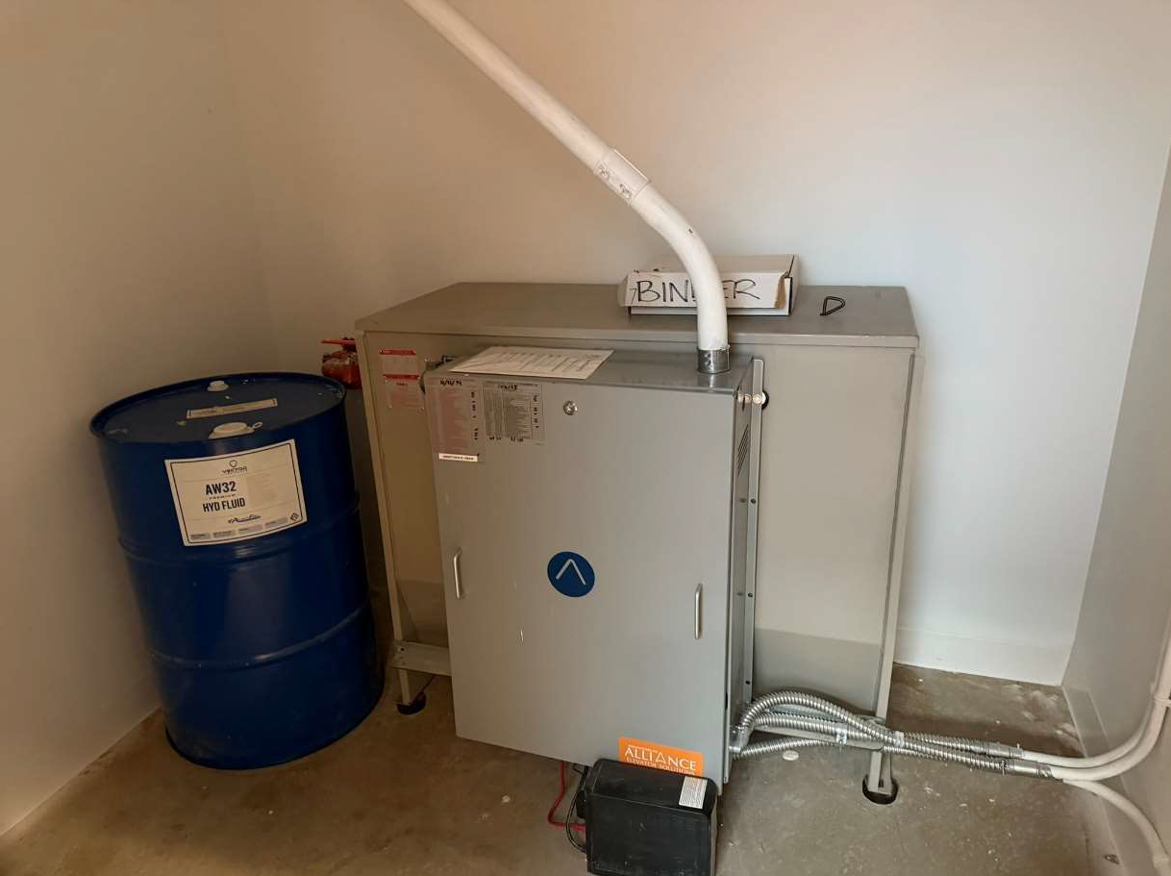
Photograph: 41 | View of the elevator mechanical system
Porsche Atlanta Northwest |  |  | 2501 Windy Road SE  Marietta, GA

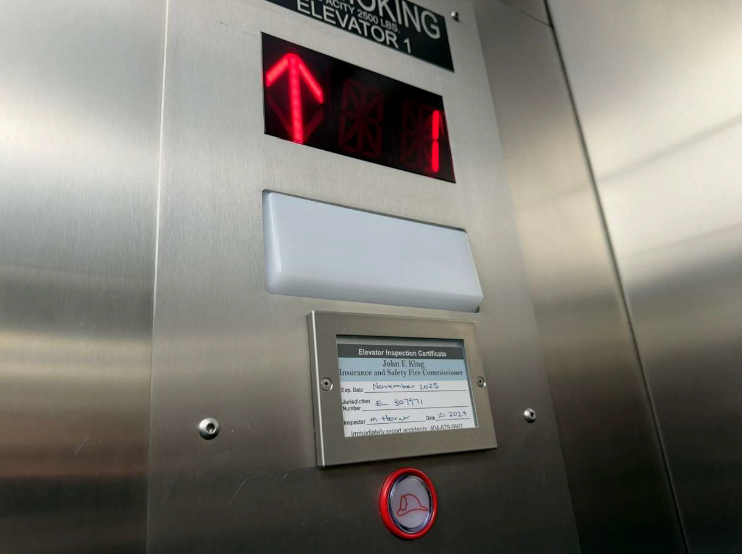
Photograph: 42 | View of the elevator located in the showroom
Porsche Atlanta Northwest |  |  | 2501 Windy Road SE  Marietta, GA

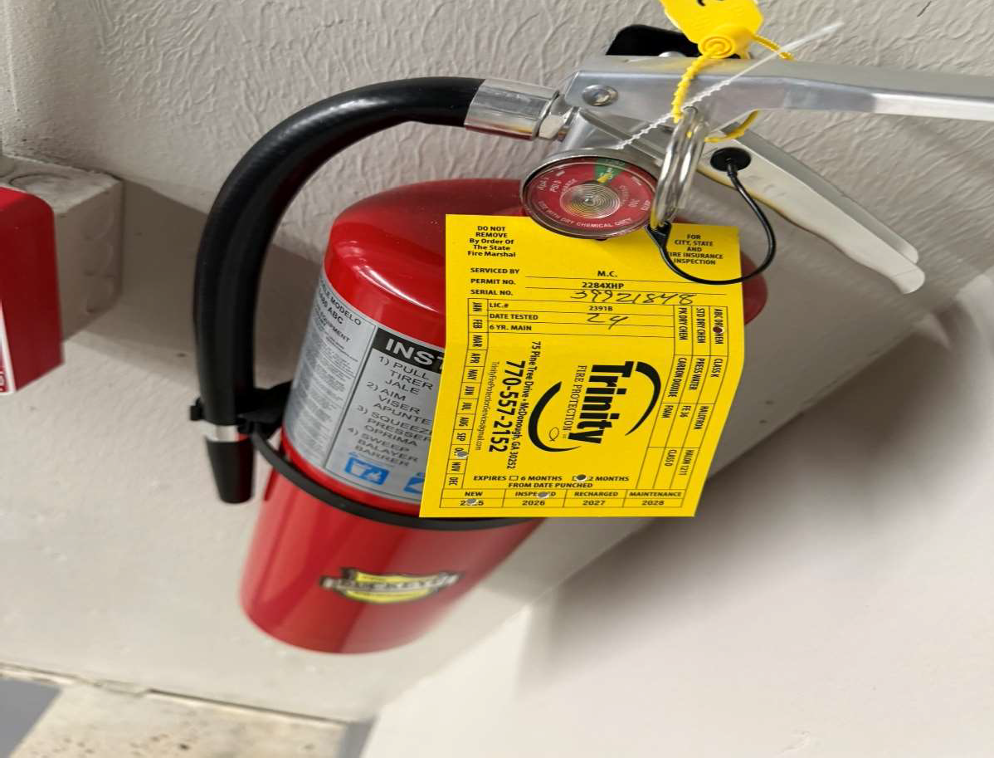
Photograph: 43 | View of a typical fire extinguisher located throughout the dealership
Porsche Atlanta Northwest |  |  | 2501 Windy Road SE  Marietta, GA

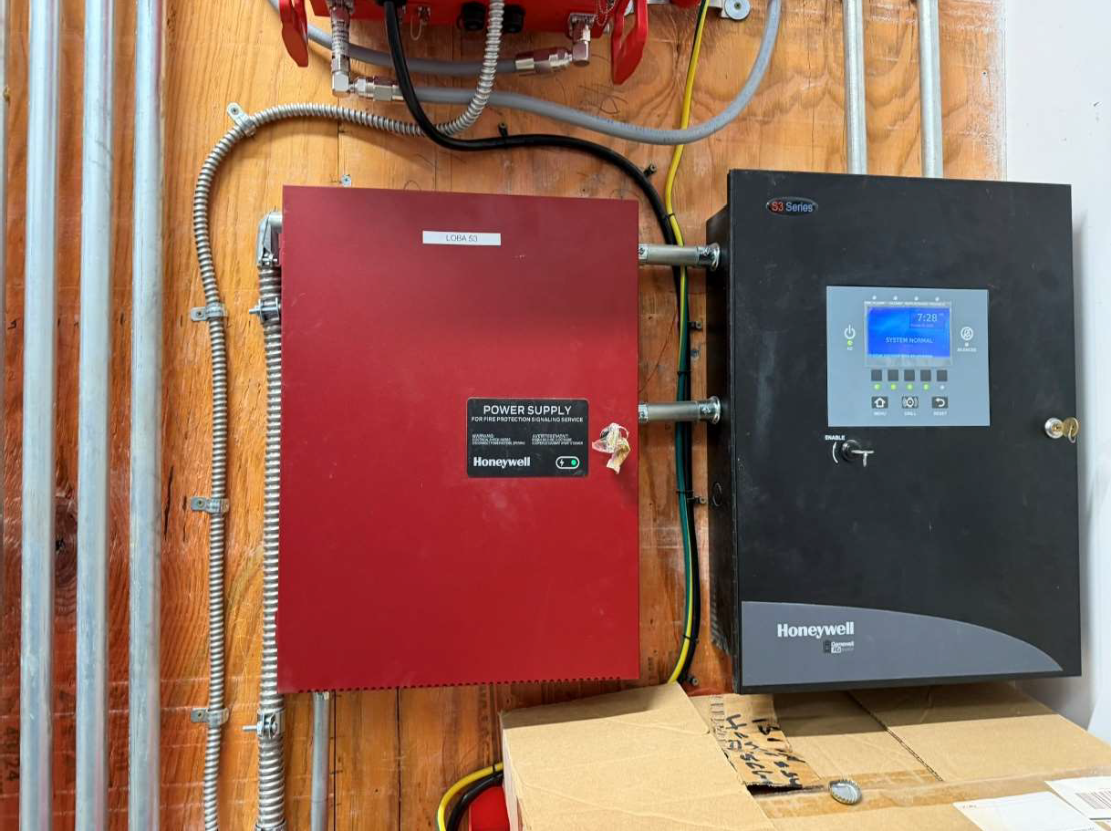
Photograph: 44 | View of the dealership fire panel
Porsche Atlanta Northwest |  |  | 2501 Windy Road SE  Marietta, GA

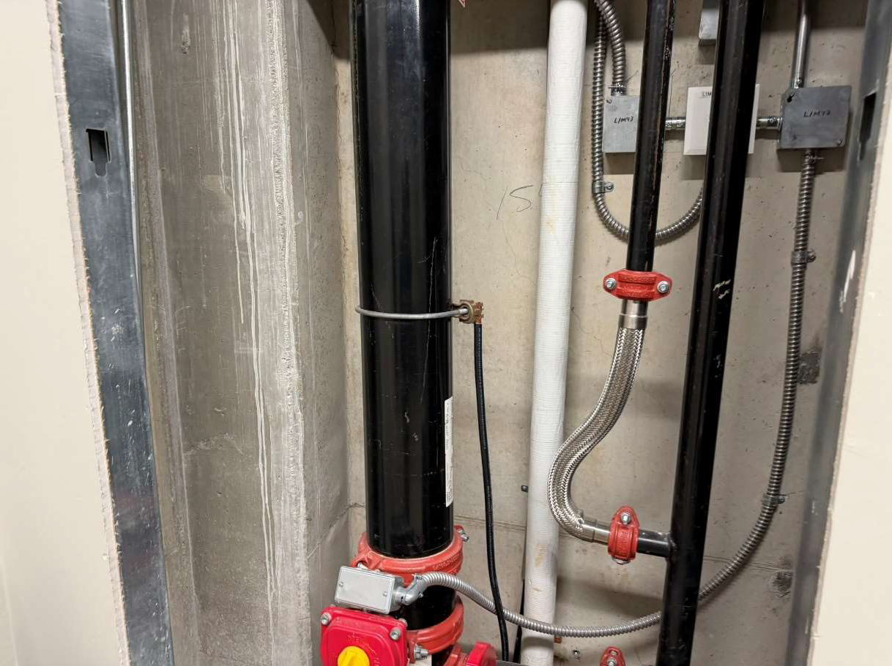
Photograph: 45 | View of the riser in the dealership riser room
Porsche Atlanta Northwest |  |  | 2501 Windy Road SE  Marietta, GA

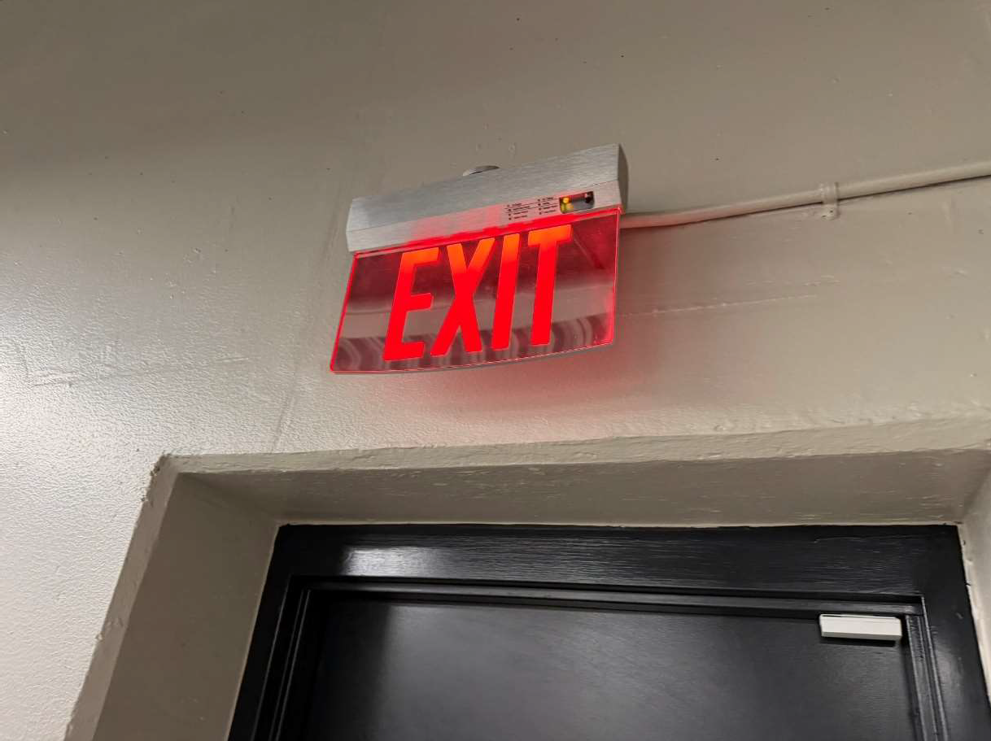
Photograph: 46 | View of a typical exit sign located throughout the dealership
Porsche Atlanta Northwest |  |  | 2501 Windy Road SE  Marietta, GA

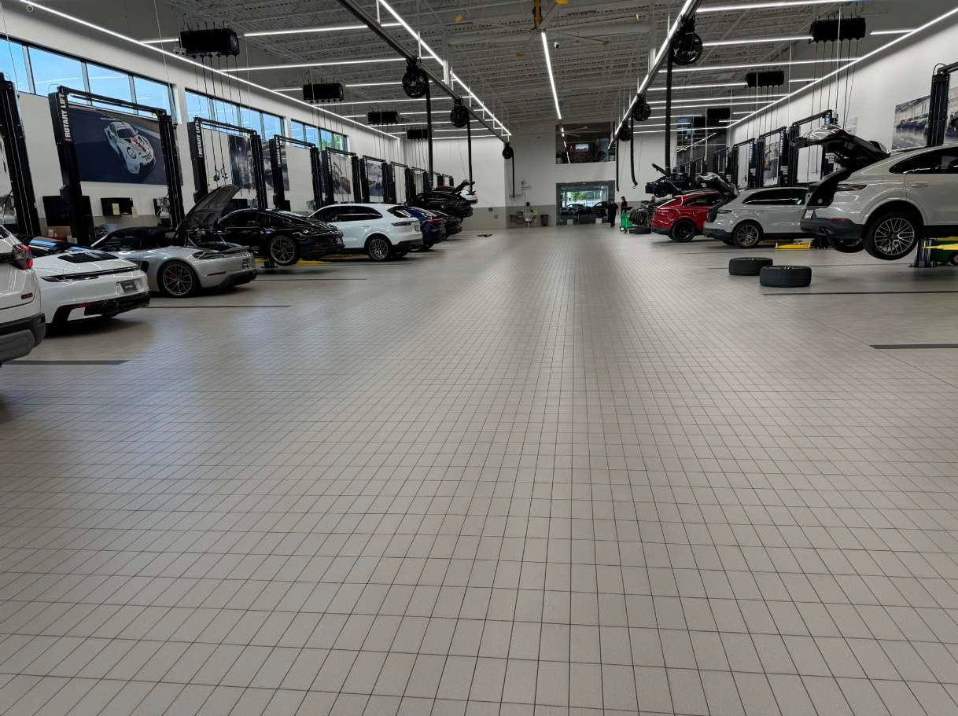
Photograph: 47 | View of the service department located in the dealership building
Porsche Atlanta Northwest |  |  | 2501 Windy Road SE  Marietta, GA

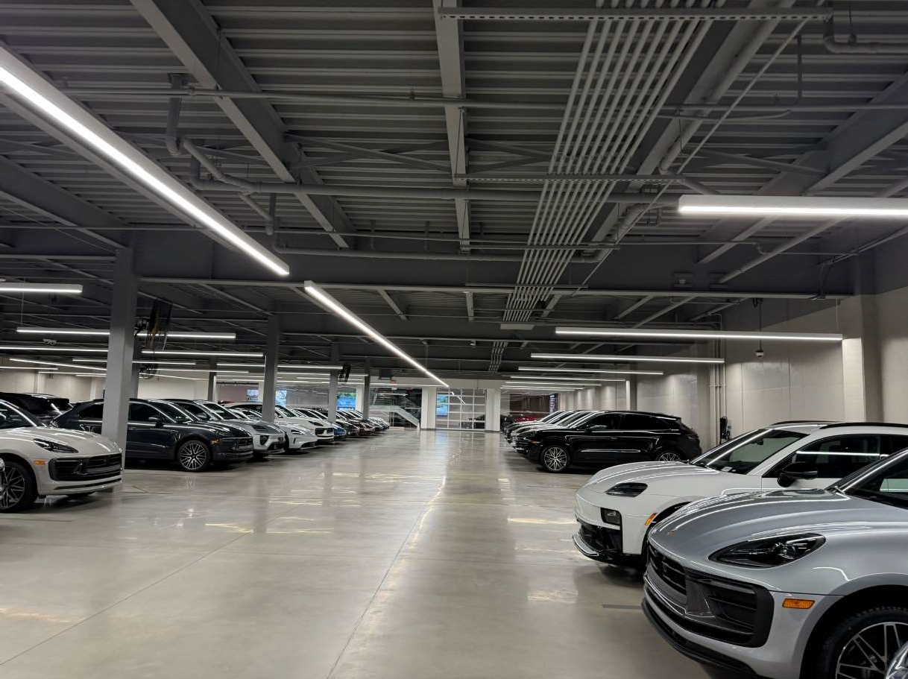
Photograph: 48 | View of the interior parking area in basement of the dealership building
Porsche Atlanta Northwest |  |  | 2501 Windy Road SE  Marietta, GA

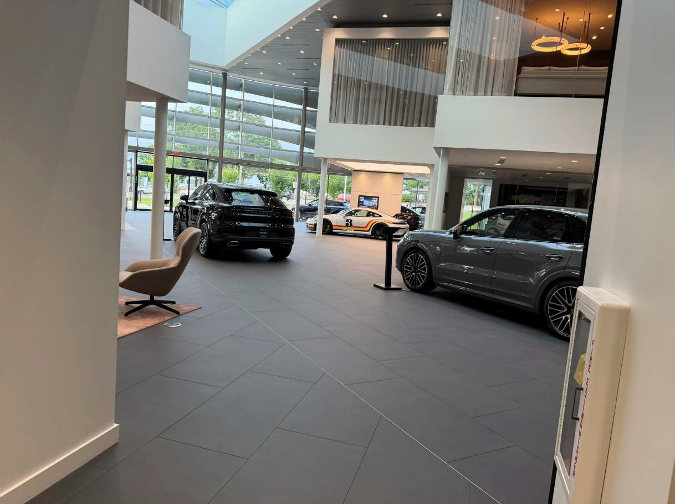
Photograph: 49 | View of the showroom in the dealership building with typical interior finishes
Porsche Atlanta Northwest |  |  | 2501 Windy Road SE  Marietta, GA

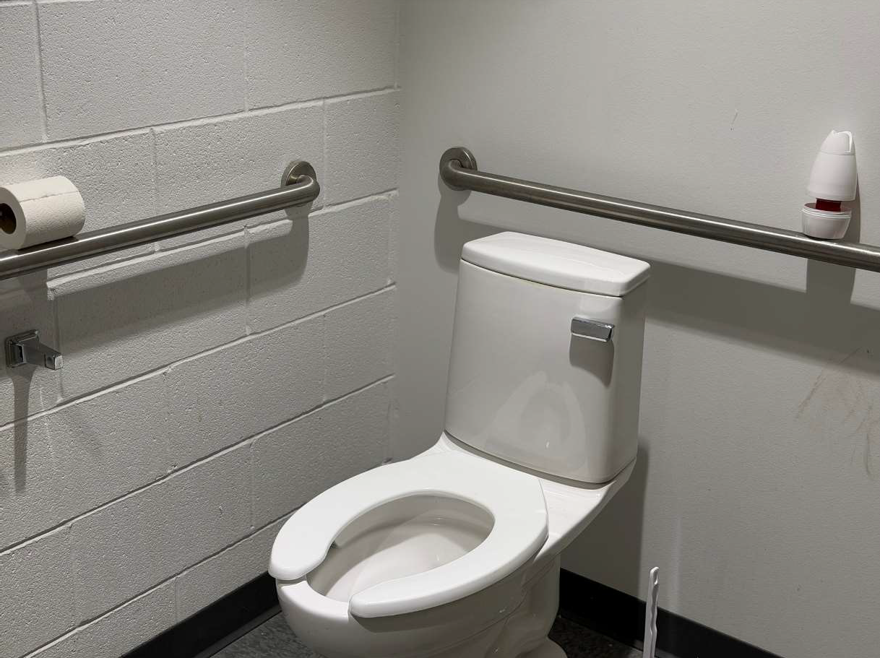
Photograph: 50 | View of the customer restroom, appearing ADA compliant
Porsche Atlanta Northwest |  |  | 2501 Windy Road SE  Marietta, GA

Appendix B
Tax Assessor Information

Cobb County, GA

Composite Summary
ParcelNumber 17080400140
PropertyAddress 2501 WINDY HILL RD
Class C4 - Auto Dealer, Full Service
Acres 7
LandSquareFootage 304920
Neighborhood 08C -
TaxDistrict (4) MARIETTA
SubdivisionName

Map
Click the image below to open and view the map.
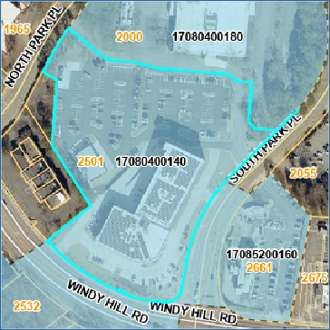
Owner
ADE 1040 LLC
C/O 2501 WINDY HILL RD LLC
3399 PEACHTREE RD NE SUITE 1700
ATLANTA GA 30326

Owner Info Last Updated 11/1/2025

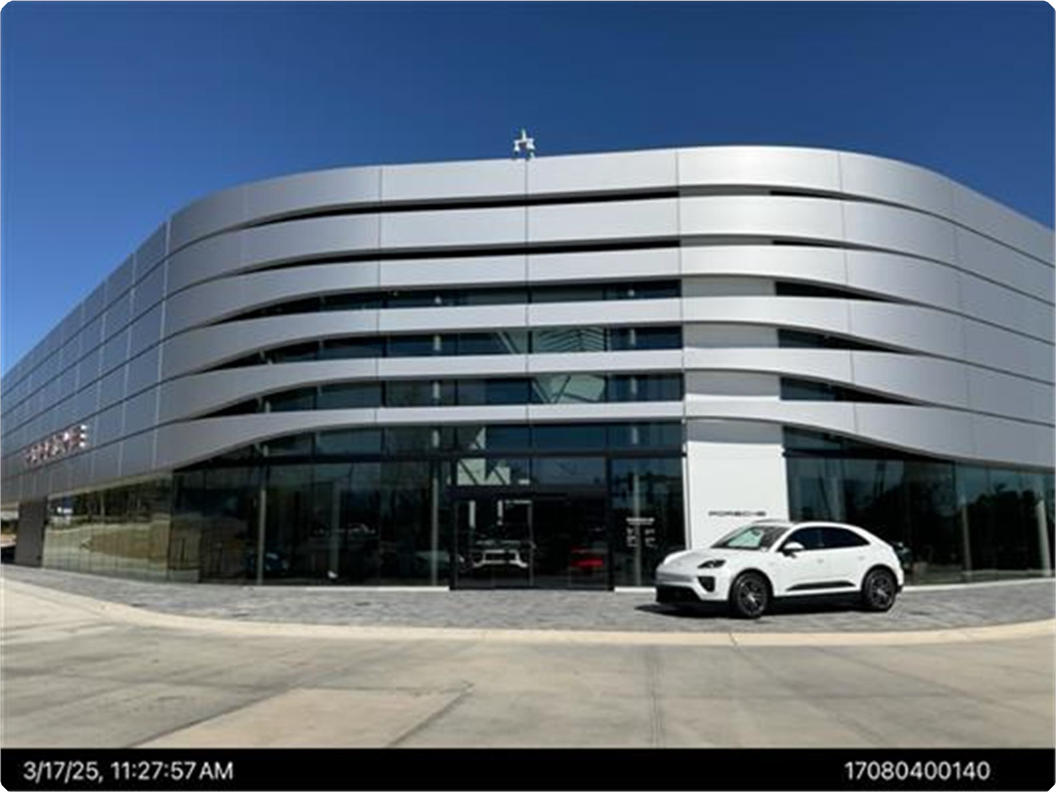
ParcelPhoto.jpg2025-03-1762798059

Appraised Values - Fair Market Values

Year | Property Class | LUC | Appraised Land | Appraised Building  Value | Total Appraised  Value
2026 | C4 | 331 | $5,276,860 | $10,855,000 | $16,131,860

 Show Historical Appraised Values
Assessed Values - 40% of Fair Market Values

Year | Assessed Land | Assessed Building  Value | Total Assessed  Value
2026 | $2,110,744 | $4,342,000 | $6,452,744

 Show Historical Assessed Values
Commercial Improvement Information
Card 1
Year Built 2024
Structure AUTO DLR F-S
Sqft 60694
Structure Test AUTO DEALER/F-SEVICE
Card 2
Year Built 2024
Structure AUTO SRV GAR
Sqft 5040
Structure Test AUTO SERVICE GARAGE
Accessory Information
Card 1
Description | Year Built | Area
PAVING ASP | 2024 | 55,000

Appeals

Tax Year | Property Type | Status
2023 | Commercial | Complete
2018 | Commercial | Complete
2015 | Commercial | Complete
2014 | Commercial | Complete

Permits

Date | Number | Amount | Purpose
07/01/2024 | BLDG2406057593 | $255,000 | TENANT FIN
10/26/2023 | BLDG2310053868 | $5,000 | RET WALL

Date | Number | Amount | Purpose
10/26/2023 | BLDG2310053867 | $5,000 | RET WALL
10/26/2023 | BLDG2310053866 | $6,500 | RET WALL
10/26/2023 | BLDG2310053865 | $40,000 | RET WALL
10/26/2023 | BLDG2310053864 | $30,000 | RET WALL
01/24/2018 | 18-00000162 | $60,500 | TRUSS/ROOF
04/25/2016 | 16-00000740 | $0 | GRADING
08/12/2015 | 15-00001661 | $2,115 | SIGN
08/12/2015 | 15-00001660 | $4,200 | SIGN
08/12/2015 | 15-00001659 | $4,200 | SIGN
12/30/2014 | 14-00002374 | $6,000 | SIGN
08/06/2014 | 14-00001449 | $34,500
01/15/2013 | 13-00000012 | $133,000
11/06/2012 | 12-00001683 | $75,000
09/06/2007 | 07-00001609 | $50,000 | REPAIR

For more Permit information, visit the Digital Plan Room OR contact Community Development at https://www.cobbcounty.gov/community - development/building-development
Sales Information

Sale Date | Sale Price Instrument | Deed Book | Deed Page | Sales Validity | Grantor | Grantee | Recording
9/29/2022 | $6,100,000 LD | 16091 | 0362 | VALID SALE | PARTNERS AT PARK PLACE, L.L.C. | ADE 1040 LLC | Click Here
2/13/1996 | $2,060,000 | 09415 | 158 |  | PARK PLACE WINDY HILL INVESTMENTS LTD | PARTNERS AT PARK PLACE LLC | Click Here

Photos
As an enhanced customer service, the Superior Court Clerk and Tax Assessors' Office has created this direct link to deed documents.
Not all deeds display on the Tax Assessors' Website! For complete deed research, visit the Superior Court Clerk's website at https://superiorcourtclerk.cobbcounty.gov/landmark

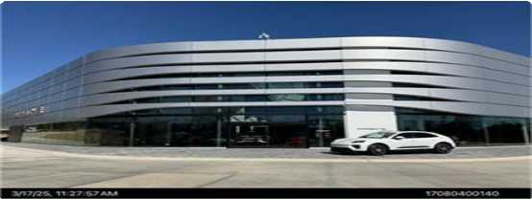

Sketches
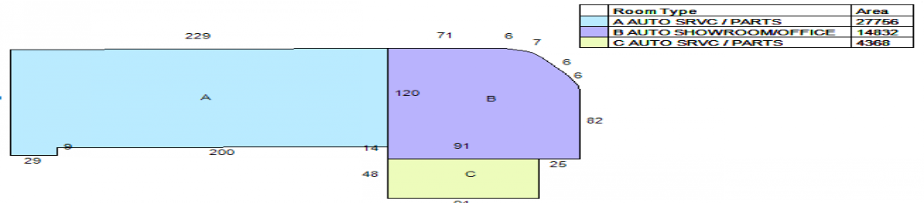
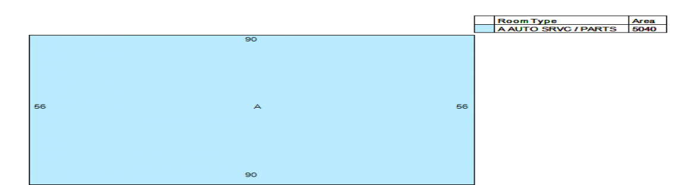

No data available for the following modules: 2026 Undeliverable Notices, Upcoming Visits, Summary - Personal Property, Current Year Business Forms, Appraised Values - Personal Property, Residential Improvement Information, Additions.

Ownership and characteristic data are the most current information available. All appraised/assessed values are as of Jan 1, 2026. Cobb County develops and updates a great assortment of GIS data for our staff and citizens to use. This data has been incorporated into the free online and mobile maps for easy access to information. It is the user's responsibility to verify any information derived from the GIS data before making any decisions or taking any actions based on the information.
| User Privacy Policy | GDPR Privacy Notice Last Data Upload: 6/13/2026, 8:41:09 AM
Contact Us Developed by


Appendix C Qualifications



Th s s to cert fy th at Kerreth M oore

has corrpeted th e course Prorerty Cord t or Assessrerts

1 5 CEU s or PDH Equ ivap ert

Kenneth Moore
7265 Wingfield Way
Cumming, GA 30041
770-653-4891
Kmoore@southernmonitoringandenv.com Environmental Scientist/Property Inspector SUMMARY
Professional Environmental Scientist with twenty-four years experience in environmental inspection and site management in the state of Georgia, North Carolina, and Florida. The sites include Federal and State agency regulated sites for underground storage tanks (USTs), State Hazardous Sites, Brownfields, and RCRA sites. Comprehensive knowledge of the Georgia EPD and Florida DEP regulations, groundwater and soil remediation techniques, air and water discharge permit compliance, and risk assessment. Additional services include: asbestos, led based paint, and mold inspection services.

EXPERIENCE
Project Manager 2007-Present
Responsibilities include management of subsurface investigations, (well installations, groundwater sampling, and soil and groundwater remediation) preparation of reports (HSRA, UST, RCRA, and Phase I/Phase II ESA reports), and sales and marketing of company.
- Conduct risk assessments of chlorinated hydrocarbon impacted sites for evaluating remediation alternatives with respect to human health, the environment, cost and feasibility
- Evaluate soil and groundwater data on UST sites to determine remedial approaches
- Communication with regulators and attorneys on project site status and activities
- Coordinate client proposals and contracts
- Perform Phase I and Phase II environmental site assessments
- Prepare Brownfield Compliance Status Reports and Corrective Action Plans
- Prepare HSRA Voluntary Remediation Applications
- Conduct regulatory compliance audits to include: Hazardous Waste Fee calculations/reporting, Form R Reporting, Waste reduction plans-Biennial Reporting, Tier II filing/SARA Title III reporting, and EPCRA Right-to Know compliance.
- Conduct asbestos inspection services in Georgia, Idaho, Arizona, Virginia, Alabama, North Carolina, South Carolina, Kentucky, Colorado, Texas, Maryland, Tennessee, and Florida
- Conduct Mold Inspection services in Georgia and Colorado
- Property Condition Assessor various sites in the Southeast
Environmental Planning Specialists, Atlanta, Georgia 2003-2007
Project Scientist/Manager
Responsibilities include management of subsurface investigations, (well installations, groundwater sampling, and soil and groundwater remediation) preparation of reports (HSRA, UST, and Phase I/Phase II ESA reports).
- Conducted risk assessments of chlorinated hydrocarbon impacted sites for evaluating remediation alternatives with respect to human health, the environment, cost and feasibility
- Develop health and safety protocol for field activities
- Communication with regulators and attorneys on project site status and activities
- Coordinate client proposals and contracts
- Prepare reimbursement claims for GA EPD
- Perform Phase I and Phase II environmental site assessments
Delta Environmental Consultants, Norcross, Georgia 2001 - 2003
Project Scientist
Participated in staff training, remediation system design and implementation, site risk assessment, budget preparation, and Corrective Action Plan (CAP) preparation.
- Conducted risk assessments of petroleum hydrocarbon impacted sites for evaluating remediation alternatives

- Prepared fate and transport groundwater modeling using Bioscreen
- Developed and implemented remediation strategies for project portfolio
- Performed remediation system design and installation
- Prepared annual budgets and cost-to-closure budgets for project sites
- Secured permits for building, air injection (UIC), and wastewater discharge (POTW)
- Trained staff for groundwater and soil sampling
- Supervised underground storage tank removals and excavations
- Acted as liaison between client and regulator
- Prepared bid packages for remediation system installation
Delta Environmental Consultants, Norcross, GA 2000 - 2001
Staff Scientist
Participated in underground storage tank soil and groundwater sampling, compliance report preparation, and field work scheduling and subcontractor oversight.
- Ensured environmental compliance with local, state, and federal agencies
- Planned, directed, and coordinated activities of designated projects
- Analyzed and compiled data concerning groundwater monitoring, soil sampling, and remediation system performance following sampling
- Developed work schedules, budgets, and timelines
- Supervised subcontractors and field technicians conducting field activities
- Prepared monitoring reports and Corrective Action Plan-Part A
- Performed soil and groundwater sampling for UST sites
- Prepared health and safety plans to ensure site safety
- Prepared work plans for field staff in portfolio
North American Environmental, Roswell, Georgia 1999 - 2000
Regional Sales Manager
Responsible for acquiring and maintaining professional business relationships within the corporate atmosphere. Knowledge of federal and local EPA guidelines regulating transportation and disposal of hazardous and non-hazardous materials, including knowledge of waste codes and federally acceptable RCRA waste disposal methods. Sales and knowledge of site assessments, UST removal and clean out, and emergency response contracts.
- Coordination of transportation and disposal of environmental waste for regional and national clients
- Handled sales of emergency response and waste disposal contracts
- Responsible for the preparation of requests for proposal for state, federal, and local agencies
- Liaison between federal regulatory agencies and client

EDUCATION

Stephen F. Austin State University, Nacogdoches, Texas  M.S., Environmental Science-Aquatic Biology | 2000
GPA: 3.5
Stephen F. Austin State University, Nacogdoches, Texas  B.S., Environmental Science/Biology | 1998
SKILLS
- AutoCADD
- Groundwater Modeling
- Preparation of compliance reports for the State of Georgia (UST, HSRA, and Brownfields)
- Soil and groundwater sampling
- Risk Based Calculations
- Remediation system installation (HVDPE, AS/SVE, iSOC)
- Perform underground injections for soil and groundwater remediation
- Army Corp. of Engineers Wetlands Classification and Functional Assessment
- Phase I and II Environmental Site Assessments
- Asbestos Inspector
- Property Condition Assessor

TRAINING
- 40-Hour Hazardous Waste Operations and Emergency Response (HAZWOPER) Health and Safety Training (Updated 8-Hour Annual Refreshers)
- AHERA certified asbestos building inspector
- North Carolina Licensed Asbestos Inspector
- Alabama Licensed Asbestos Inspector
- Colorado Licensed Asbestos Inspector
- Kentucky Licensed Asbestos Inspector
- Virginia Licensed Asbestos Inspector
- South Carolina Licensed Asbestos Inspector
- Michigan Licensed Asbestos Inspector
- ASTM Property Condition Assessor

